NVR4.0 USER MANUAL

--- HD NVR
Thank you for purchasing our products, if you have any questions or requirements, please feel free to contact us.
We will update the contents of user manual based on product function add or change, which will be issued in new version without prior notice. The user manual only provides guidance for users. Images, chart and other attachment used in this document are only used to illustrate the feathers and usage.
The user manual is applicable to HD NVR below:
Series | Model | Name
TS9XXXQ | TS9108Q3 | NVR
TS9XXXQ | TS9216Q3 | NVR
TS9XXXQ | TS9236Q3 | NVR
TS8XXXA | TS8104A3 | NVR
TS8XXXA | TS8108A3 | NVR
TS8XXXA | TS8216A3 | NVR
TS8xxxC | TS8216C3 | NVR
TS8xxxC | TS8225C3 | NVR
TS6xxxC | TS6104C3 | NVR
TS6xxxC | TS6108C3 | NVR
TS8xxxD | TS8108D3 | NVR
TS8xxxD | TS8116D3 | NVR
TS8x36M | TS8836M | NVR
TS8x36M | TS8436M | NVR

Catalogue
1. Product Overview 8
1.1. Introduction 8
1.2. Features 8
2. Operation Instructions 12
2.1. Mouse operation Instructions 12
2.2. Input method instruction 13
2.3. Interface Instruction 13
2.3.1. Interface factor instruction 13
2.3.2. Common button introduction 14
2.3.3. Preview window icon instruction 14
2.4. Menu Instruction 15
2.4.1. Bottom Menu 15
2.4.2. Context Menu 15
2.4.3. Cloud Logging State 16
3. Device Installment 17
3.1. Installment Attention 17
3.2. Hard Disk Installation 18
3.3. Connection Peripherals 19
3.3.1. Basic Device Connection 19
4. System Function Introduction 21
4.1. Login/Close Down 21
4.1.1. Cloud password settings 21
4.1.2. Login 21
4.1.3. User Log Out 22
4.1.4. Close System 23
4.2. Boot wizard 23
4.3. Video Management 28
4.3.1. Search Device 28
4.3.2. Add Device 29
4.3.3. Delete Device 30
4.3.4. Manual Add 30
4.3.5. Modify IP address 31
4.3.6. Batch Modify IP address 32
4.3.7. IPC Setting 33
4.3.8. NVR Network Settings 34
4.3.9. Modify the channel name 36
4.3.10. Network tool 37
4.4. IPC Setting 38
4.4.1. Check IPC General Information 38
4.4.2. Time Setting 39
4.4.3. IPC Video Capture Configure 41
4.4.4. IPC Preview Setting 41
4.4.5. IPC Stream Setting 43
4.4.6. IPC Advanced Setting 44
4.4.7. IPC Remote Maintenance 45
4.5. Screen Layout 47
4.6. Rotation 48
4.7. Electronic zoom in and zoom out 48
4.8. Output Adjust 49
4.9. Screenshot 50
4.9.1. Snapshot Capture 50
4.9.2. Picture Management 50
4.9.3. Picture Export 52
4.10. Recording Function 52
4.10.1. Set Recording Plan 52
4.10.2. Playback Recording 54
4.10.3. Playabck Control 54
4.10.4. Video Backup 55
4.11. System Settings 57
4.11.1. General Setting 57
4.11.2. Time Setting 57
4.11.3. User Setting 58
4.11.4. RS232 Setting 61
4.11.5. Advanced Setting 63
4.11.6. Preview Setting 64
4.11.7. Stream Setting 66
4.11.8. Network Setting 68
4.11.9. GB28181 Setting 69
4.11.10. Email Setting 71
4.11.11. Motion Detection Alarm 73
4.11.12. Video Lost Alarm 76
4.11.13. Local I/O Alarm Setting 77
4.11.14. IPC I/O Alarm Setting 78
4.11.15. Advanced Alarm Setting 80
4.11.16. System Log 82
4.11.17. System Maintenance 83
4.11.18. System Basic Information 84
4.11.19. Auto Upgrade 84
4.11.20. Storage Device 85
5. Appendix 87
5.1. Hard Disk Capacity Calculation 87
5.1.1. Hard Disk Total Capacity Corresponding Video Days Calculation 87
5.1.2. FAQ 88

Product Overview

Introduction
NVR4.0 series are the latest professional monitoring storage devices which have been developed and launched by our company, adopting Hisilicon video processing chipset,integrating excellent video encoder video codec algorithm .NVR4.0 series products own four features that are stability,ease of use, intelligence and perfection. Our NVRs use H.264, H.265, H.265+ compression algorithm which support ultralow code rate and super-long cable access and embedded Linux real time operation system,support ONVIF protocal,achieve IPC’S auto search,preview and recording without commissioning; APP one second connection to show picture,let our customer enjoy more perfect experience.

Features
- Real time monitoring
  - VGA/HDMI output simultaneously
  - Electronic Zoom in
  - Screen layout optional
  - Auto search, add, preview and recording.
  - Fast drag to adjust channel sequence
  - All channel 1080P/4K decode
  - APP connect and display picture immediately
  - Private protocol to access ultralow code rate, super-long cable IPC
  - Preview and rotation
- Compression Storage
  - Adopt H.264+, H.265+ video compression technology with lower compressed code
  - Snapshot
  - USB/Mobile HDD backup
  - support different recording strategies including overlay-write and stoping recording.
  - Multi-channel Video backup at the same time
- Recording Playback
  - real-time video recording, motion detection video recording and I/O alarm recording
  - Video search
  - Remote access and video replay through Seetong App and Seetong client
  - Smart playback
  - Rewind 30s and fast forward 30s
- Alarm Function
  - Motion detection alarm
  - Stream lost alarm
  - IPC I/O alarm
  - Alarm video recording
  - Send alarm email and attachment
  - Flashing when alarm event is triggered
  - Snapshot when alarm event is triggered
- Remote configuration Function
  - time synchronization between IPC and NVR
  - NVR configure IPC encoding parameter and video capture parameter
  - NVR configure IPC channel OSD.
- Network Function
  - Adopt device function to remote control without complex setting,achieve network transmition easily
  - IP address modify and DHCP
  - Choose Seetong’s client/mobile APP system for remote control
  - Real-time monitoring using Seetong client or Seetong app / remote PTZ control
  - Different users can access to NVR at the same time
  - Flexible IP address
  - Cloud password settings
  - IP self-adapt when conflict happens
- User Management
  - Customizable local user /network user permission
  - HDD abnormal loss alarm
  - Log operation
  - Timing reboot and automatic maintenance
  - Support at most 16 users
- Other functions
  - Boot wizard
  - 16-channel-NVR/25-channnel-NVR/36-channel-NVR provide USB mouse reuse feature. .
  - Different ways of upgrading, including U-disk,Seetong client, Seetong app and self-upgrade.
  - U-disk recovery in case that your NVR work abnormally.
  - Replace boot logo using our logo-replace tool.
  - 25-channel-NVR and 36-channel-NVR as well as our H.265 series also support audio
  - Multi-language version switch
  - H.265 series all support Project-Engineering Mode
  - Audio listen through Seetong client and Seetong app
  - Modify IP address of ONVIF device, and also a batch of modification to a series of IPC devices.
  - Watch dog and auto reboot after power off and sudden failure

Operation Instructions

Mouse operation Instructions
Mouse key | Action | Function | Example
Left Key | Click | Select | 1.Select a preview window,playback window and picture  2.Select a button,edit box,combobox, check box
Left Key | Double click | Zoom in/out | 1.Switch different screen layout during preview  2. Double click on the video recording bar to start video replay
Left Key | Drag | Adjust channel distribution | Exchange two channels
Middle Key | Roll | Change current view | 1.Zoom in playback scale; 2.scroll to view ipc device search list  3.scroll to view screenshot search list;
Right Key | Click | Return | Single click to close current window
Right Key | Press Right mouse button for more than 5s | Set NVR revolution to 1024x768 | Press Right mouse button for more than 5s in any dialog. Revolution will be set to 1024x768

Input method instruction
Name | Key Instruction | Function instruction
Number | 0～9 | Input number from 0～9
Character | ！@ # $ % ^ & * ( ) – { } :＂｜？＜＞ | Input symbol
English | a～z A～Z | Input English letters
Big/Small | Shift | Capital letters/lowercase letters switch
Chinese/English | Ctrl | Chinese and English Switch
Delete | ← | Delete last character

Interface Instruction

Interface factor instruction
Name | Operation | Function Operation | Example
Button | Left click | Save or Cancel | Application,confirm, cancel
Button | Left click | Open sub window | NVR network setting,wizard,video resource setting
Edit Box | Left click | Modify | Modify channel name
Drop-down box | Left click | Select | Change language,select resolution
List Box | Roll | Change current view | View search list and added-device list
Check Box | Left click | Select or Cancel | Copy a channel to other channel
Character | Null | Instruction | Headline, Name

Common button introduction
Name | Function | Name | Function
Close | Close user operation window | Copy | Copy the channel setting to other channels
Application | Save configuration and put into effect.It won’t close current window | Default | Set all parameters to default.
Confirm | Save configuration and put into effect. It will close current window | Check All | Select all items of current window
Cancel | Cancel just now operation | Single check | Select one item of current window
Details | Explanation to some function

Preview window icon instruction
Preview window icon | Instruction | Preview window icon | Instruction
 | Recording |  | Window setting alarm without trigger
 | Window remote control |  | Window move alarm
 | IO alarm detected |  | IO alarm has been set up but without trigger

Menu Instruction
Bottom menu:system setting, screen layout,rotation, zoom in/out, output adjust, PTZ control, snapshot, snapshot filemanager, recording plan setting, video replay, system close, audio switch
Context menu:video management,system setting, video replay, recording plan setting, screen layout, snapshot, remote IPC setting, PTZ control, snapshot filemanager, output adjust, system close
Status menu:cloud logging status,cloud ID,disk capibiliy information, QR code

Bottom Menu
Move mouse to screen bottom,will popup following menu

Context Menu
Right click on desktop to popup following menu :
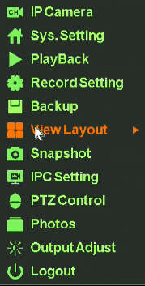

Cloud Logging State
Move your mouse to the top of the NVR screen and you’ll see the QR code.
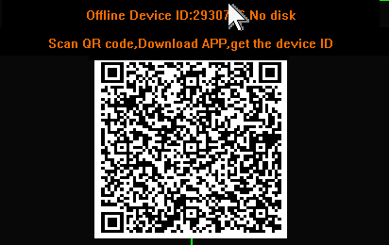

Device Installment

Installment Attention
As professional monitoring device, when user use our HD NVR, Please read below information before use
- Device should keep away from moist,high temperature and strong magnetism, please put in well ventilated areas
- Please use formal normal SATA hard disk.
- Please confirm equipment ground correction,power supply can’t pass operation voltage range of power work and suggest user to use standard power
- Don’t power off during device running, please close our device through system software firstly then outage in case had disk damage

Hard Disk Installation
Note:switch off power before installation.
Step 1: twist off the sideway sreew of NVR case,take down upper cover plate
Step 2: align screw-socket on HDD and case bottom plate,screw on HDD screw and fix
Step 3: connect hard disk data line to main board and the other to HDD.
Step 4:cover upper cover plate and fix screw
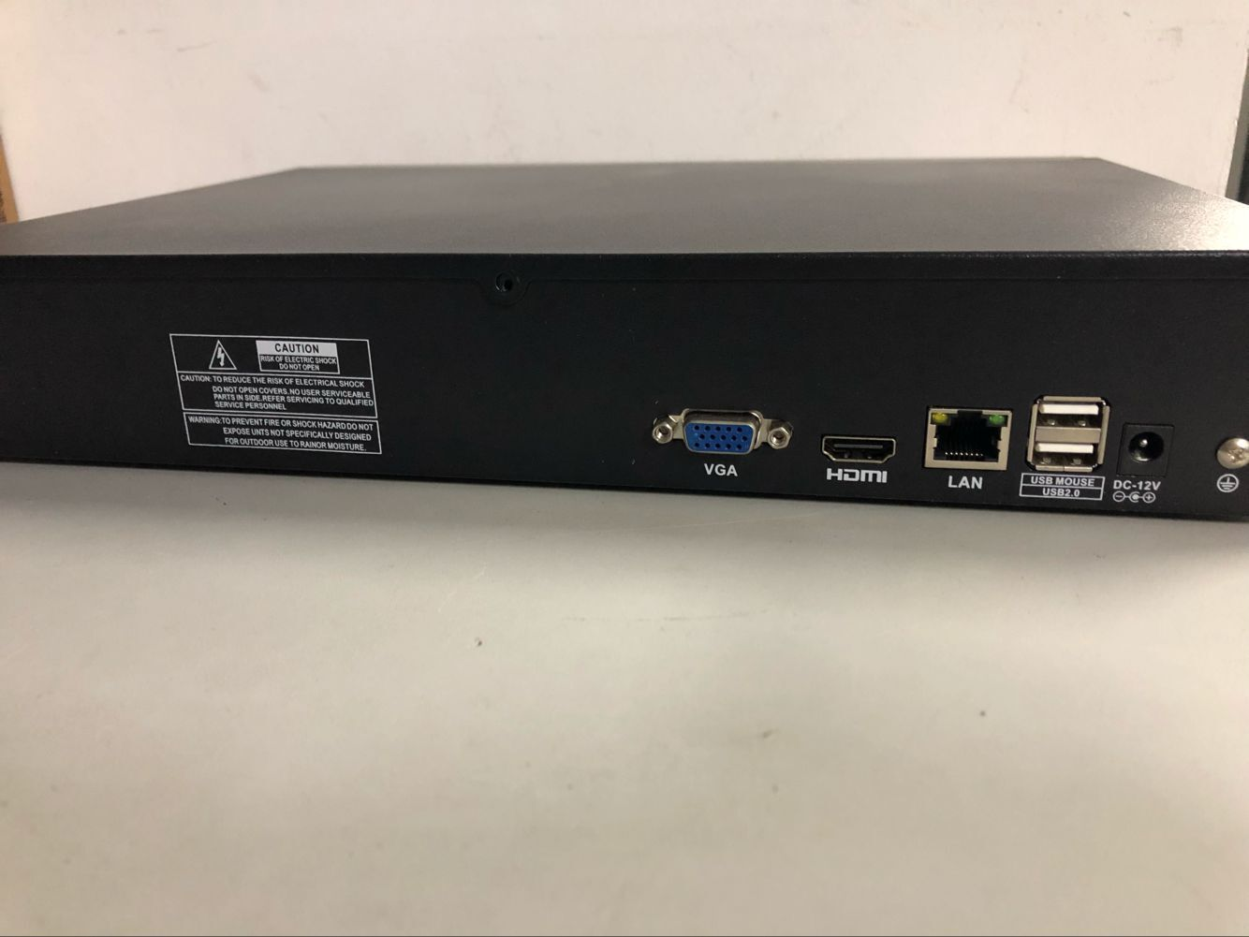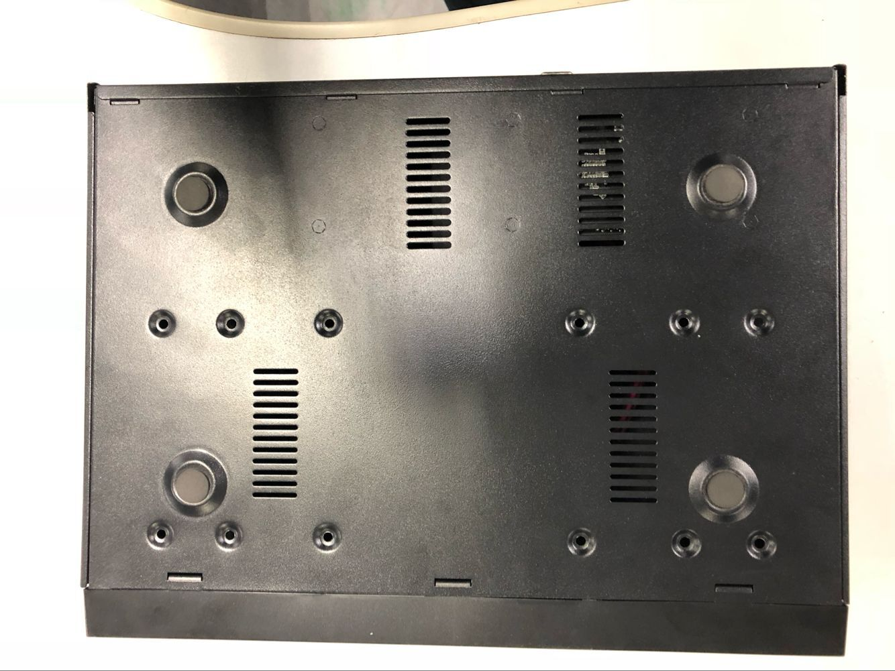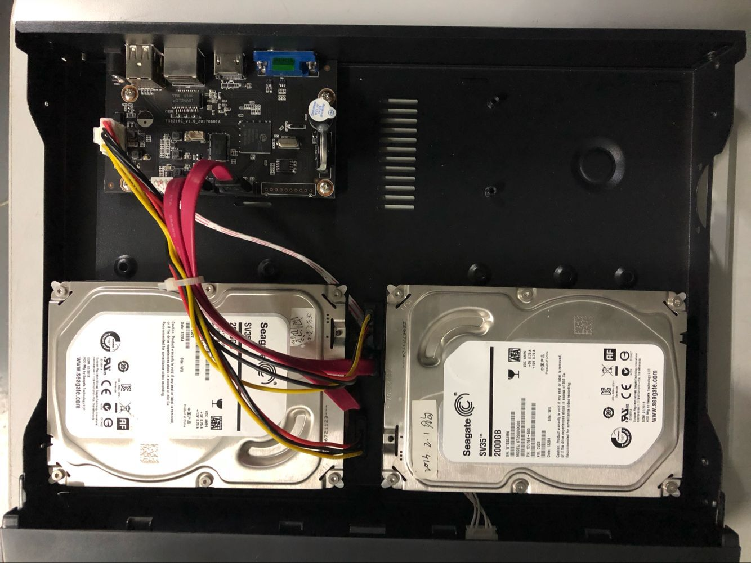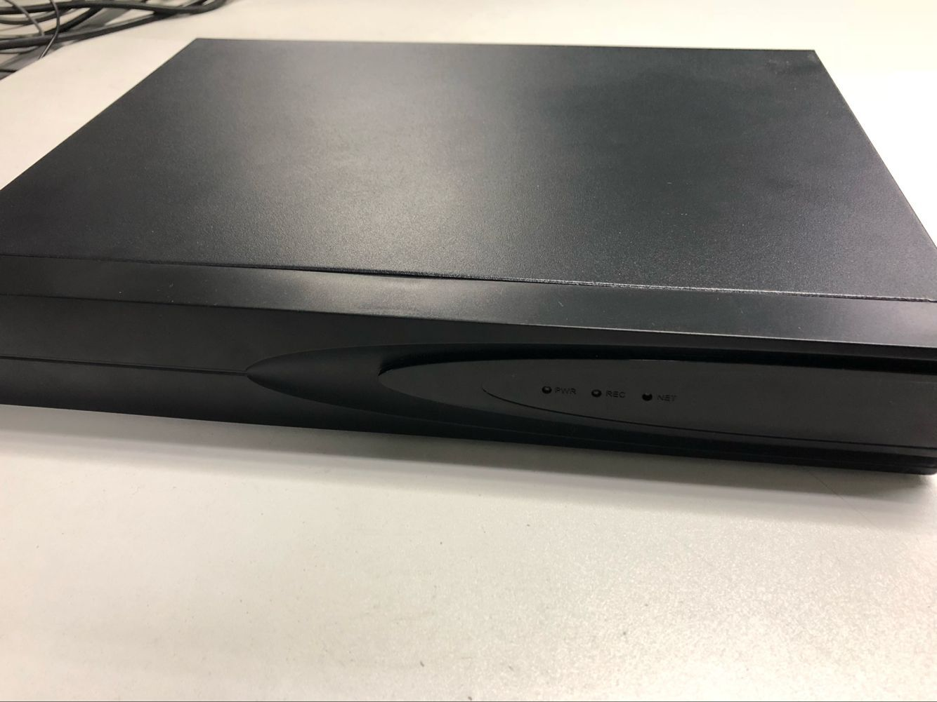
1 2 3 4

Connection Peripherals

Basic Device Connection
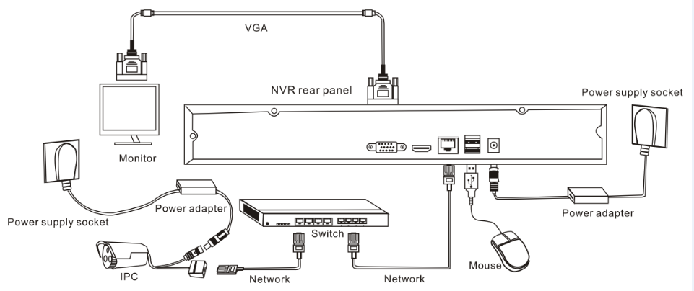
Non-POE NVR device connection diagram

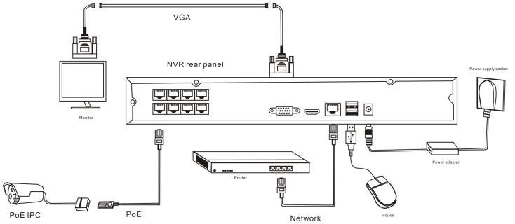
POE NVR device connection diagram

System Function Introduction

Login/Close Down

Cloud password settings
When NVR system starts at the first time with the access of the Internet. You need to input cloud password to ensure that your NVR is online, as the following picture shows:
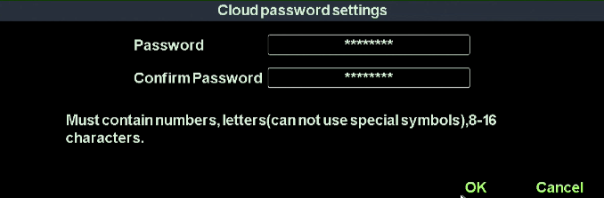

Login
When NVR system starts,it will search and connect IPC devices automatically and then popup login dialog, as the following picture shows:
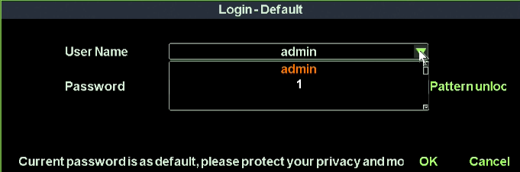
Operation steps :
- Left click “user name” context box and input user name.Default:admin;
- Left click “password ”context box and input user name. Default ;123456;
- Left click “OK”button to validate your user info.

User Log Out
Function instruction:Log out after you have saved the configuration in case that unidentified user access to your NVR.You can also configure an auto-logout parameter to log out automatically.
Operation steps:manual log out, enter system main menu---right click ---select “close system”---click on“logout” button
Auto log out,enter main menu---right click---select“system setting”---general,set auto log out time

Close System
Function instruction:reboot or shut the system down
Operation steps:
- Left click ‘Quit’button in system main menu
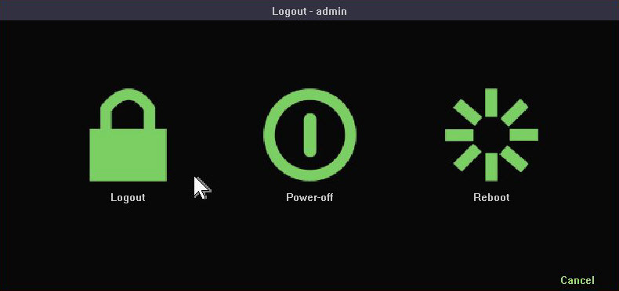
- Left click ‘Shutdown’, the system will close

Boot wizard
Function instruction: Help user make a basic configuration
Operation steps:
Setting 1: Set up system language,menu transparency,device number,auto logout time and whether the wizard window shows again when you reboot again.
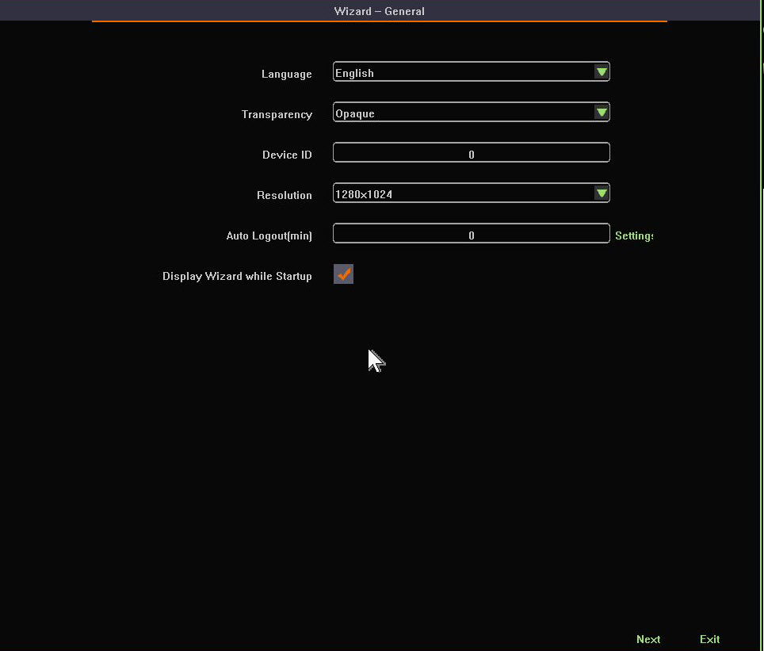
Setting 2:Set up date format, date, time zone, daylight saving time
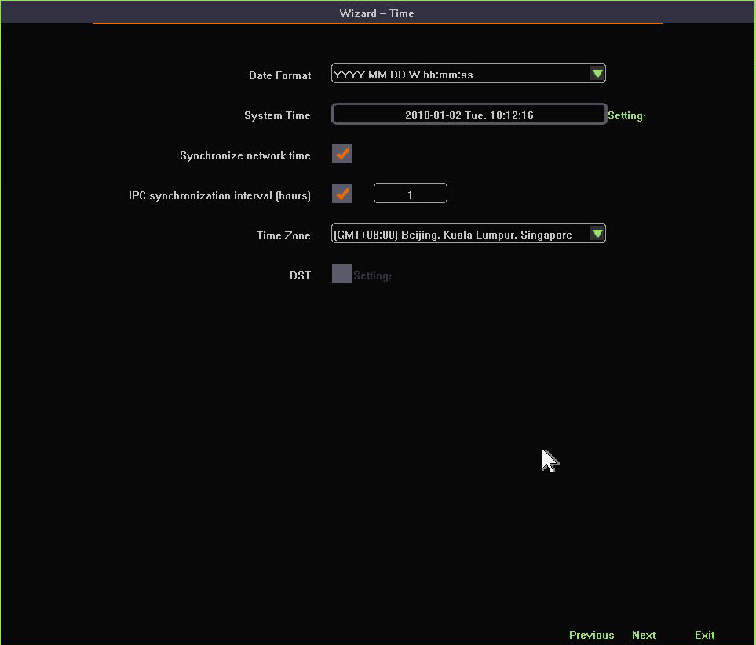
Setting 3:Network settings
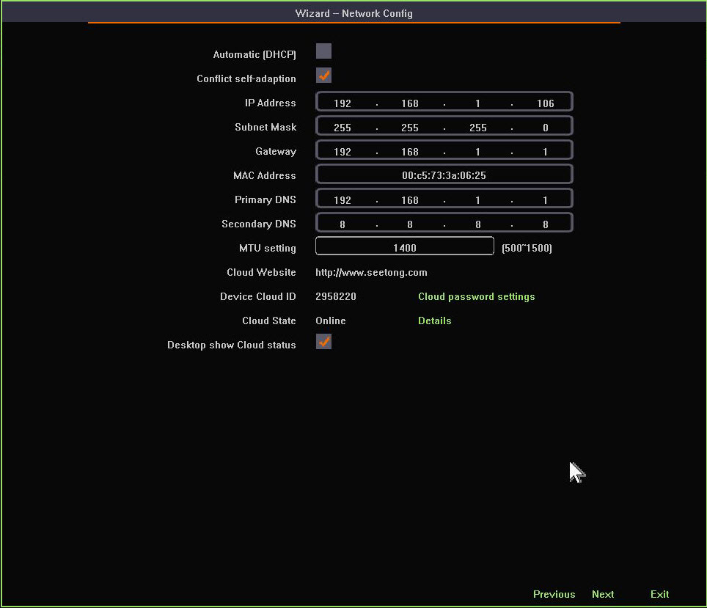
Setting 4:Scan QR code to download Seetong app and get NVR’s device ID
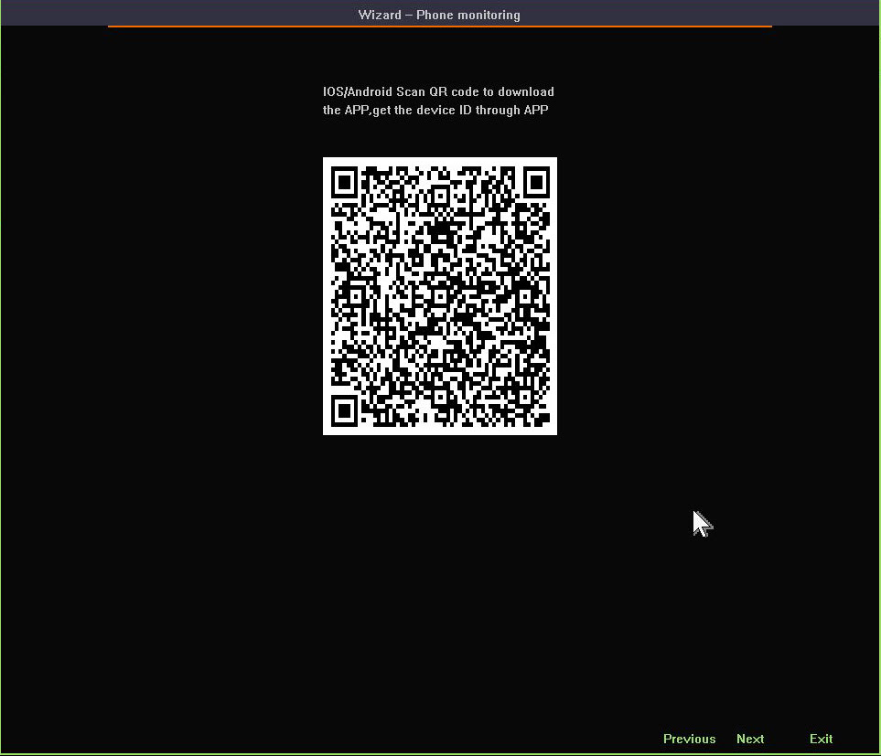
Setting 5:HDD formatting and recording strategy
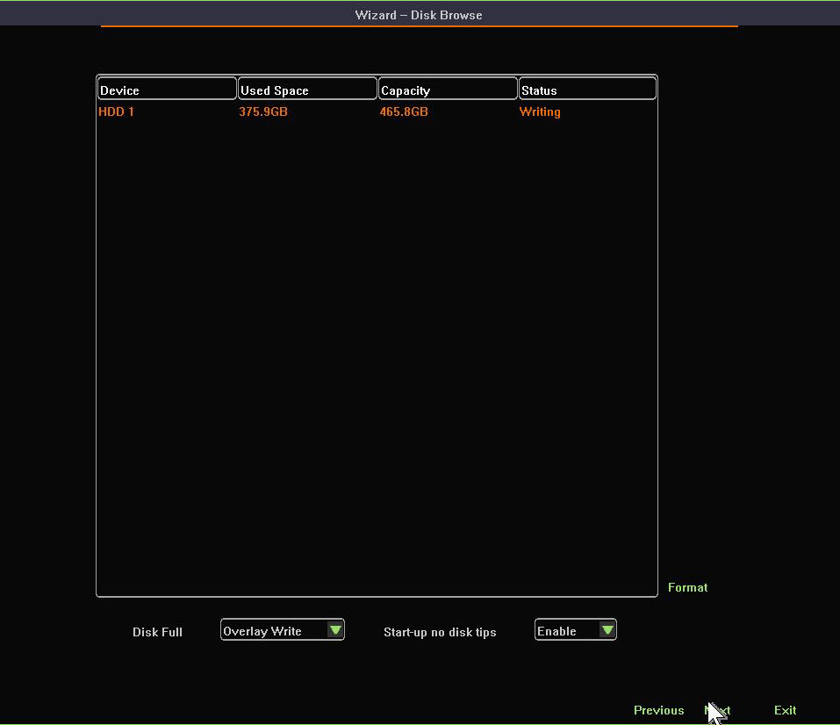
Setting 6:List all IPC devices. Left click ‘OK’ button to finish the wizard.

Video Management

Search Device
Function instruction:Search all private protocal IPC devices under the same network. Especially, ONVIF devices must have the same network segment or else ONVIF device won’t appear in the Device list.
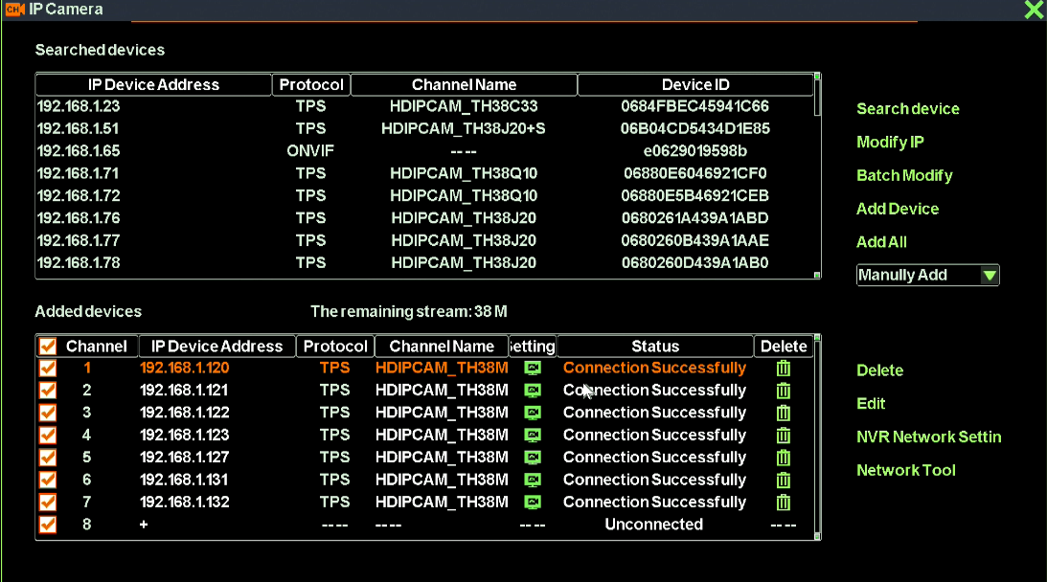
Operation steps:Right-click on desktop, and then select video management in context menu. Click on ‘search’ button and finish the search operation.
Remarks: When you change the device-add method to ‘Automatic Add’, NVR will automatically search devices in you LAN each time you enter Video Management interface. Otherwise, NVR search devices only when you click ‘search device’ button.

Add Device
Function instruction:Add private or ONVIF protocol IPC devices to NVR
Operation steps:
- Right-click on desktop and then select video management. Select one item in the device list.
- Tick check boxes of the devices and click ‘Add Device’ button, you’ll add devices to added-device list
Remarks: Double-click alse can add devices to the list.

Delete Device
Function instruction:Used to delete IPC device
Operation steps:
- Turn to video management window.
- When you need to delete only one device in the list, just click on the icon
- When you need to delete many devices in the list, tick check boxes of the devices and then click on the ‘Delete’ button.

Manual Add
Function instruction :used to add IPC devices manually
Operation steps :
- Turn to video management window and double-click on the ‘+’.System turns to a new dialog as the following picture shows:
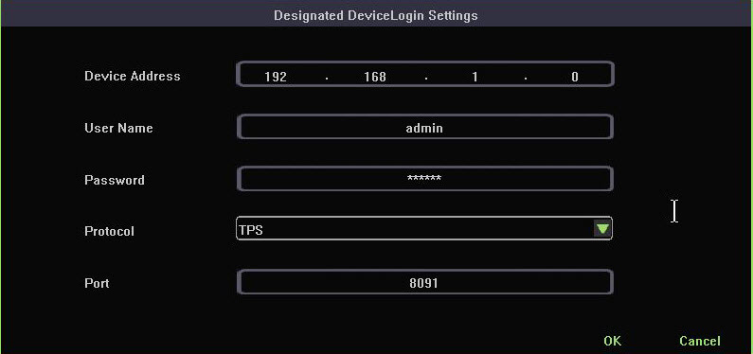
- Input the IP address, user name, password, treaty, port and left-click ‘OK’ button to finish the operation
REMARKS: If your want to add an ONVIF device to NVR, you need to change the protocol type to ONVIF.

Modify IP address
Function instruction: Modify the IP address of a device
Operation steps:
- Turn to video management window and select an item in the device list.
- Left click on ‘Modify device’ button
- Input the new IP address, gateway, netmask and finish the operation.
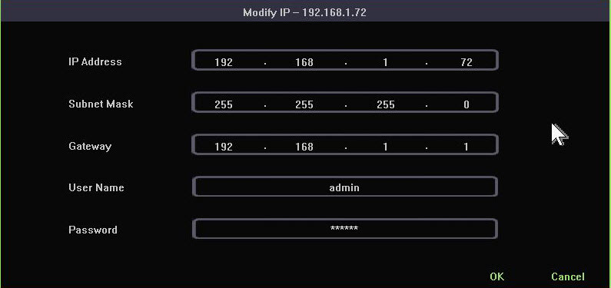

Batch Modify IP address
Function instruction: Modify IP address of series of IPC device
Operation steps:
- Turn to video management window and select an item in the device list.
- Left click on ‘Batch Modify’ button.
- Input the start IP address, gateway, netmask and finish the operation.
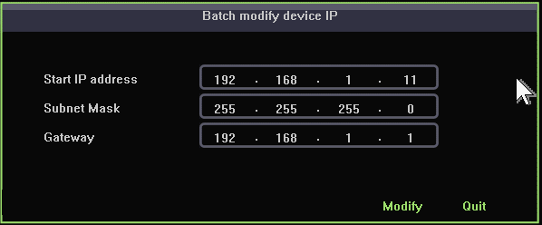

IPC Setting
Function instruction: Used to setup IPC configuration.
Operation steps:
- Turn to video management window and select an item in the device list.
- Left click on ‘’ icon. As the following picture shows:
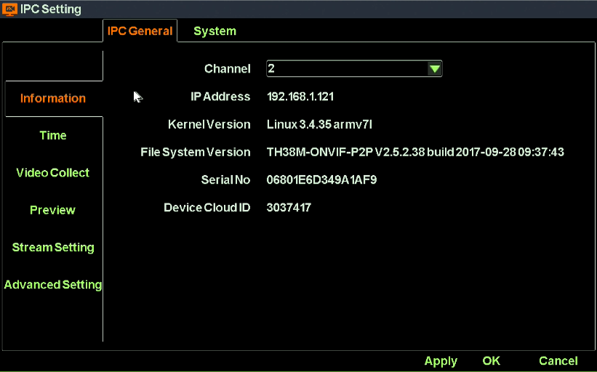

NVR Network Settings
Function instruction:Used to examine and set NVR network information
Operation steps:
- Turn to video management window and select an item in the device list.
- Left click on ‘NVR Network Setting’ button.
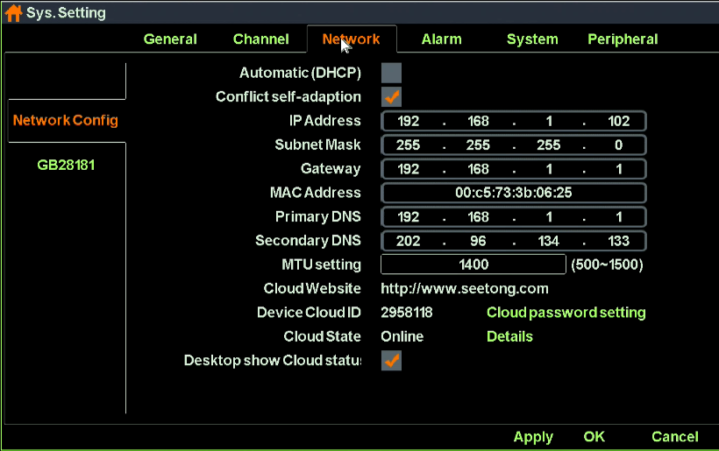
Detailed function list
IP Name | Function Description | Remarks
IP Address | Used to set/modify NVR’s IP address
Subnet Mask | Used to show NVR’s subnet mask information
Gateway | Used to show NVR’s gateway address
Primary DNS | Show NVR primary DNS information
Secondary DNS | Show NVR secondary information
MAC ADDRESS | Used to show NVR MAC address information
Auto acquire IP（DHCP） | Used to gain IP address automatically | When USE DHCP, you can’t modify IP address manually
IP Self-adapt | Used to self-adapt IP address when IP conflict occurs
Cloud Number | Show NVR device ID
Website | Show website of cloud platform
Cloud State | Show NVR P2P state | You can remote access to NVR device only when the Cloud State is ‘online’
Cloud desktop show | Control whether you would like to see P2P state at the top of desktop
Cloud password setting | Used to set up or modify Cloud password
Details | Offer simple solutions when your NVR can not get online
Long network line support | If you tick the checkbox, your POE devices can support long network line transport. Otherwise, your POE devices can support at most 120m  Transport.
Close Vlan | Tick the checkbos if you need to search the POE devices in your LAN.

Modify the channel name
Function instruction: Used to modify IPC OSD
Operation steps: Left click ‘IP camera’ in contextmenu. Select one channel and click ‘Modify the channel name’ button. As the following picture shows:
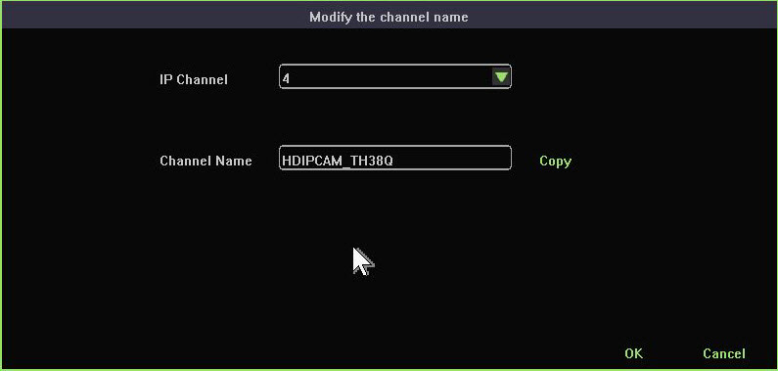

Network tool
Function instruction: Examine your current network condition
Operation steps:
- Left click ‘IP camera’ in contextmenu.
- Click ‘Network Tool’button. System turns to network tool window as the following picture shows:
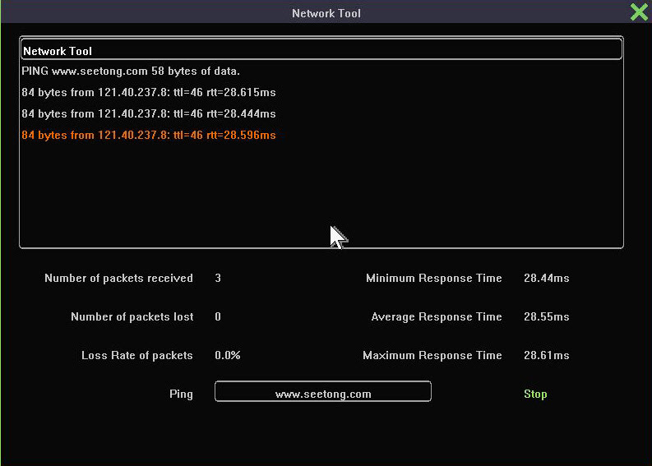
3. Click ‘start’ button, this tool will send ARP packet to destination. The default destination is ‘www.seetong.com’
4. After you click ‘stop’ button, this tool will give you a statistic of the current network information.
5. You can also input your own IP address, domain name or localhost to check your network condition.

IPC Setting

Check IPC General Information
Function instruction: Used to check IPC information, such as IPC system kernel version, file system, product serial number,software version and so on.
Operation steps: Right-click on desktop, select ‘IPC setting’ and turn to ‘IPC General-Information’ window. As the following picture shows:

Time Setting
Function instruction: Set date, system time, time zone, time synchronization
Operation steps: Right-click on desktop, select ‘IPC setting’ and turn to ‘time’ window.
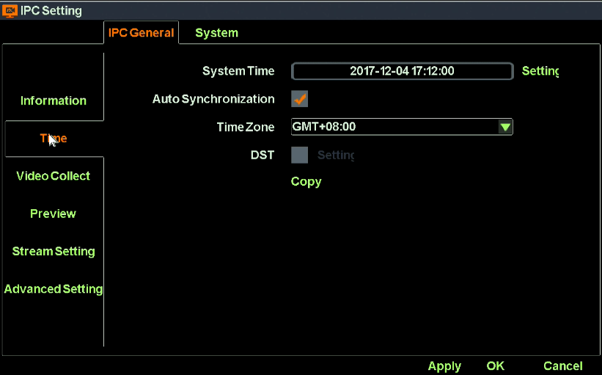
Detailed function list :
Function Name | Function Description | Remarks
Time Set | Used to set IPC’s system time
Self-Synchronizing | Used to synchronize system time with internet | IPC will proofread with network server only after it connect to the internet
Time Zone | Set the time zone of IPC | Choose correct time zone before checking time.
Daylight Saving Time | Used to set IPC daylight saving time’s start and end or clock’delay or advance
Copy | Copy selected channels time to all other channels

IPC Video Capture Configure
Function instruection: Used to configure IPC Video Capture parameters including brightness, saturation, sharpness, contrast, WDR mode, star mode, Corridor mode and etc.
Operation steps: Right click on desktop, select ‘IPC Setting’ and turn to ‘IPC Video Capture Configure’ window. As the following picture shows:
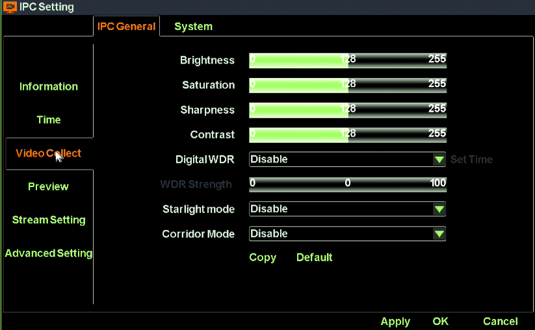

IPC Preview Setting
Function instruction: Used to configure IPC OSD information, Title Position, Time Position and Time Format.
Operation steps: Right click on desktop, select ‘IPC Setting’ and turn to ‘IPC Preview Setting’ window. As the following picture shows:
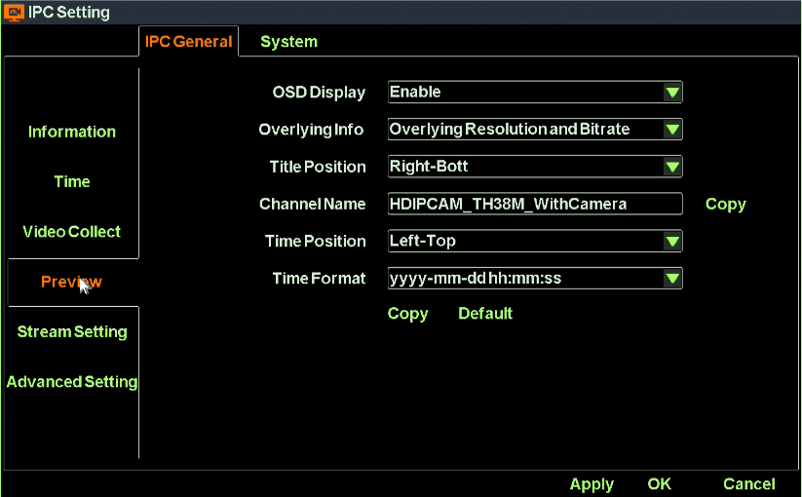
Detailed function list :
Function Name | Function Description
IP Channel | Show the channel number of current setting
OSD Show | show/hide OSD info
Overlap additional information | Set overlap additional information, including ‘no overlay’,overlay resolution’,overlay code rate, “overlay resolution and code rate”
Headline position | Heading message positon setting, support top left,bottom left,top right,bottom right
Channel Name | Channel name setting, support number,character,capital and small letter and Chinese input
Time position | User set channel overlay position, support top left,bottom left,uppder right, bottom right
Time show format | User set channel time format

IPC Stream Setting
Function instruction: Used to Configure encode parameters of main stream and sub stream.
Operation steps: Right click on desktop, select ‘IPC Setting’ and turn to ‘IPC Stream Setting’ window. As the following picture shows:
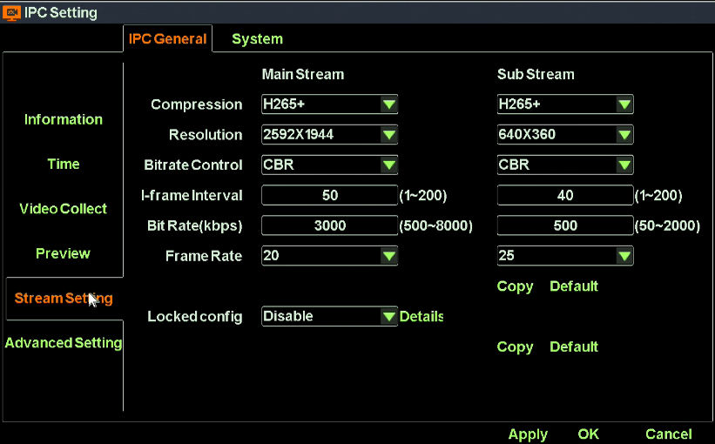
Detailed function list:
Function name | Function Description
IP channel | Set current channel number
Encoding format | Main/sub stream encoding format setting,support H.264, H.265,H.265+.
Resolution ratio | Main/sub stream resolution ratio setting, NVR provide resolution ratio option based on IPC ability level
Bit rate control | Main/sub stream bitrate control setting,support VBR and CBR
I-frame interval | Main/sub stream I-frame interver setting, range from 1-200
Bit rate | Main/sub stream bit rate setting, range from 100~10000kbps
Frame rate | Main/sub stream frame rate setting, the larger the frame rate, the fluency is better
Locked Config | Enabled. If the device config are modified by NVR. It’ll be binded to device. Otherwise, It’ll be binded the most appropriate config.
Locked Config | Disabled. IPC encode parameters will not change unless NVR local config changes.

IPC Advanced Setting
Function instruction: Used to configure advanced parametres including Full Netcom, WDR mode, Private Data, IRCut mode and etc.
Operation steps: Right click on desktop, select ‘IPC Setting’ and turn to ‘IPC Advanced Setting’ window. As the following picture shows:
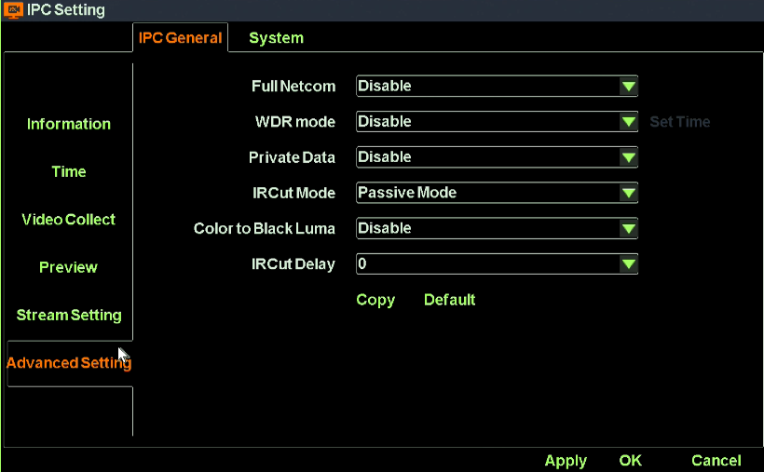

IPC Remote Maintenance

Upgrade IPC
Function instruction: upgrade IPC using u-disk
Operation steps;
- Select the channel you want to upgrade. Right-click on desktop and select ‘IPC setting’submenu.
- Turn to IPC maintainence window
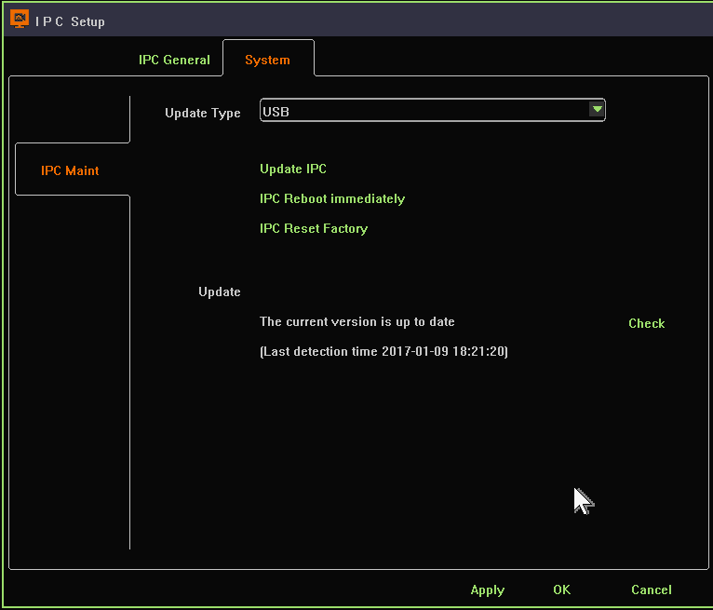
- Insert U-disk and left-click on ‘upgrade IPC’ button
- Select the correct fireware, click ‘OK’ button and finish IPC upgrade operation

Restart IPC Device
Function instruction: Used to restart IPC through operation on NVR
Operation steps:
- Select the channel you want to upgrade. Right-click on desktop and select ‘IPC setting’submenu.
2. Turn to IPC maintainence window
3. Left click on ‘IPC reboot immediately’button and finish the operation.

IPC Reset Factory
Function instruction:IPC reset factory operation
Operation steps:
- Select the channel you want to reset. Right-click on desktop and select ‘IPC setting’submenu.
- Turn to IPC maintainence window
- Left click on ‘IPC reset factory’ button and finish the operation.

Remote Upgrade
Function instruction: IPC upgrade through web server online.
Operation steps:
- Select the channel you want to upgrade. Right-click on desktop and select ‘IPC setting’ submenu.
- Turn to IPC maintainence window
- Left click on ‘check’ button, if there’s new version on web server, click ‘upgrade’ button and then it’ll download the newest fireware on web server and upgrade automatic.
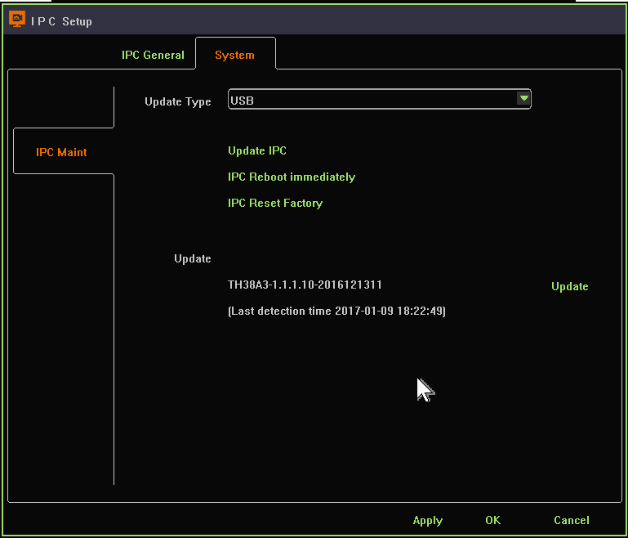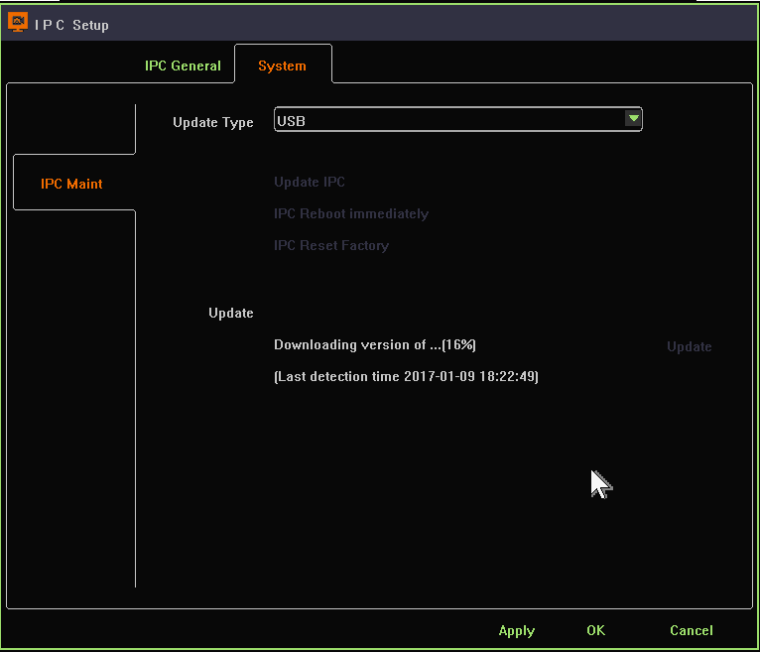

Screen Layout
Function instruction: Used to adjust different screen layout, including view 1/2/4/6/8/9/10/16/25/36
Operation steps:Right-click on desktop and select ‘View Layout’ submenu. Then, you can change different screen layout.

Rotation
Function instruction: Take turns to preview video stream according to current screen layout
Operation steps:
- Move mouse to bottom menu and click on the rotation icon, as the following picture shows:
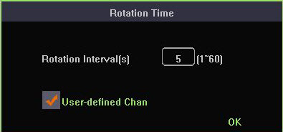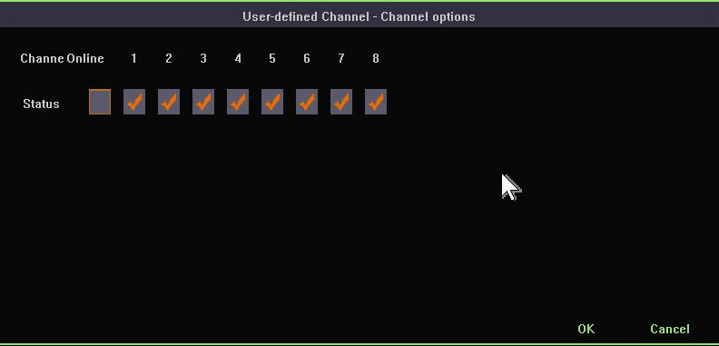
- Check out the channels that you want to rotate.
- Click ‘OK’ to start rotation.
- Click on the rotation icon again will stop current rotation operation.

Electronic zoom in and zoom out
Function instruction: Zoom in/out part of the region to get details of the video stream.
Operation steps:
- Select a channel that you want to zoom in
- Move mouse to bottom menu and click on the magnifier icon
- Scroll mouse middle button to zoom in or out.
- Click single picture or drag the green area to zoom in
- Right-click to terminate zoom-in operation
Remarks: Zoom in/out is effective only in 4-channel-NVR, 8-channel-NVR and 16-channel-NVR

Output Adjust
Function instruction: Used to set different output effects
Operation steps:
- Move mouse to bottom menu and click on the ‘output to adjust’ icon
- Left click the combobox which include 4 modes.
- Select ‘custom’ mode and you’ll be able to adjust the parameters on your own.
- Click on ‘OK’ button to save current configuration and close the window.

Screenshot
Used to snapshot any frame picture of real time video monitoring or replay and manage the pictures

Snapshot Capture
Function instruction: real-time video monitor picture capture, frame picture capture in replay, linkage alarm picture capture and store them into HDD
Operation steps:
- Right-click on desktop and select snapshot capture. Mouse pointer will become ‘tongs’ shape
- Left click on screenshot video window, you’ll get a jpg picture.

Picture Management
Function instruction: Manage screenshots and there are three types of screenshots, manual screenshots, alarm screenshots and video screenshots
Operation steps:
- Left click ‘picture management’in contextmenu, system open picture management window as the following picture
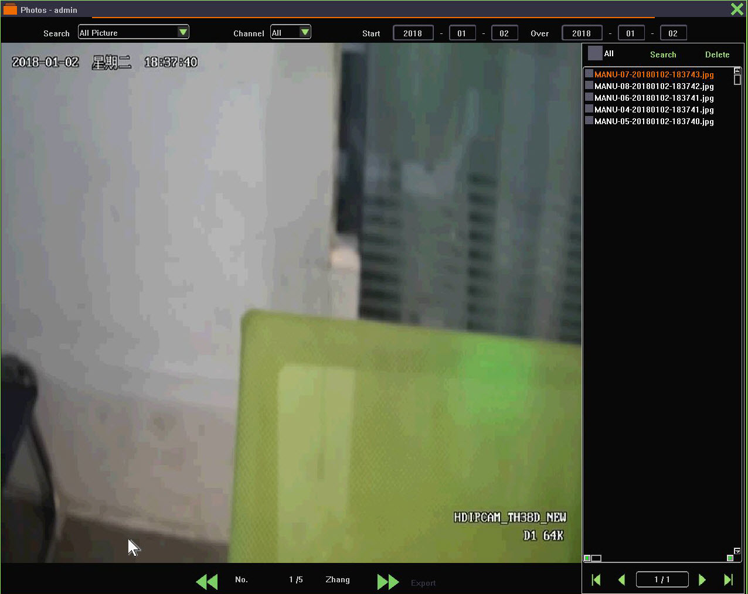
- Left click’search type’combobox and select one type, default is ‘all screenshots’
- Click’channel’ combobox and choose the channel number of screenshot, default is channel 1.
- Left click’start/end’date editbox,input time quantum of screenshot, default is your system time.
- After finishing the search condition setting, Left click’search’ button,system will show eligible screenshot result in the list on the right.Select an item and you’ll see the screenshot.
- Select a picture and then click ‘delete’ button, you’ll be able to delete picture files.

Picture Export
Function instruction: backup screenshot file into U-disk or move them into HDD
Operation steps
- Insert U-disk into USB interface on NVR
- Left click any picture’s checkbox, or select all checkbox to backup picture
- Left click’Picture Export’ button,wait until backup finish.

Recording Function

Set Recording Plan
Function instruction: set recording plan
Operation steps:
- Left click ‘recording plan’ in contextmenu or in bottom menu, system will open a new window as the following shows:
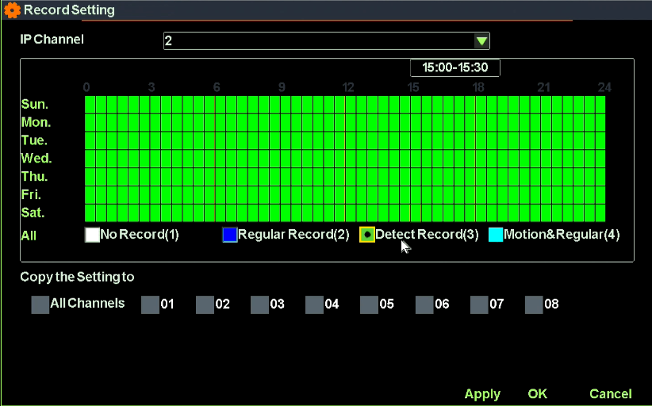
- Left click ’No Record’ or ‘Regular Record’ or ‘Motion Detect Record’ or ‘Motion & Regular Record’ and drag to make a recording plan you’d like. You can also click on the button on the left to make a simple and rapid recording plan.
- After finishing your recording plan setting, you can copy current configuration to other channels.
Remarks: When you set current record plan to ‘Motion Detect Record’, NVR will automatically record only when motion incident happens.
When you set current record plan to ‘Motion & Regular Record’, NVR will make motion record when motion incident happens and make regular record when there’s no motion incident.

Playback Recording
Function instruction: Used to search video recording data.
Operation steps:
- Left click ‘playback’ buttom in the bottom menu or in contextmenu, system will open video replay window.
- Left click calendar and date, orange color indicate that there’s video recording data while gray indicate there’s no video recording data.
- Select the record type, channel you want to search. There’s 3 types of record type, common, motion, alarm. The color of Common video is blue while alarm is red and motion is green.
- After finishing your setting, double-click on the video recording bar to play the video recording data.

Playabck Control
Function instruction: Used to operate on video recording data, such as playback, suspend, fast backward, smart fast backward, speed, slow, backup, start/close audio, screenshot, full screen playback, playback window proportion adjustment, rewind down 30s, fast forward 30s.

Serial number | Name | Explaination | Serial number |  | Name | Explaination
1 | Fast backward | Recording back fastly | 11 | Audio |  | start/close video audio
2 | Choose Fast backward | Choose back fastly | 12 | 1/4 screenlayout switch |  | playback recording
3 | Play/Suspend | Click to play/suspend | 13 | Aspect ratio |  | Cut 4:3/16:9 playabck screen ratio
4 | Stop | Stop playback | 14 | Full screen |  | Playback full screen
5 | Screenshot | Capture to recording playback | 15 | Rewind down 30s |  | Rewind down 30s
6 | Time fast forward | Fast forward by time | 16 | Fast forward 30s |  | Fast forward 30s
7 | Smart fast forward | Different play speed between regular record and motion record | 17 | Time slice |  | Set record playback time point
8 | Speed | Video fast forward | 18 | Earliest Play |  | If ticked, NVR will automatically start playback from earliest time point
9 | Digital Zoom | Zoom in record video | 19 | Close |  | Exit playback page
10 | Backup | Enter backup interface

Video Backup
Function instruction: backup video file to U-disk or HDD
Operation steps:
- Left click ‘backup’ button in video playback toolbar,system will open a new dialog as the following picture shows:
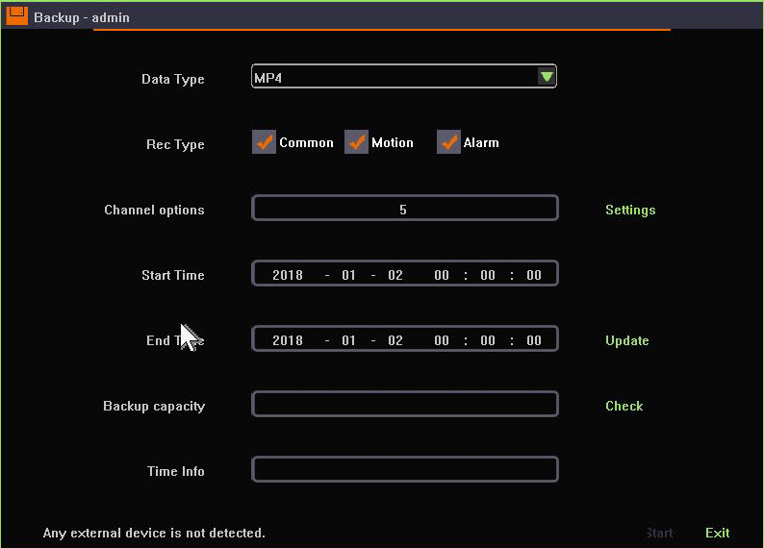
- Left click data type’s pull down option, choose backup video format, default format: H.264 AVI
- Mouse choose alarm types such as ‘ type,alarm,common,manual,move’,system default ; all types video.
- Left click’ setting’ button, choose video backup channel.
- Left click start and end time, click update button after time setting, can check certain time quantum need capacity size.
- Insert USB into NVR interface when backup, click’check’ button in single page, system will detect USB
- Click’start’ to backup selected video, time information will show backup’s timing.
Tips: Install media player and you’ll be able to check the video backups.

System Settings

General Setting
Function instruction: general function setting like language, transparency , output resolution, wizard, auto log out time
Operation steps:Left click ‘system setting’ in contextmenu or in bottom menu, system opens a new dialog as the following picture shows:
Detailed Function List
Function Name | Function Description
Language | Set NVR system language,support Chinese/English and so on
Transparency | Set user interface transparency,support transparent/translucence/opacity
Resolution | Set the resolution from NVR to display, support 3840×2160,1920×1080,1440x900,1366x768,1280×1024,  1024×768 and so on
Auto Lock Time | Set auto lock time
Start Show Guide | After checking the function, it will show wizard window when system starts.
Boot wizard | Open wizard configure window

Time Setting
Function instruction: set time, date format, time zone setting, time synchronize
Operation steps:
- Left click system setting in main menu or context menu, system will open setting window.
Detailed Function List
Function Name | Function Description | Remarks
Date Format | Set date format such as YYYY-MM-DD W hh:mm:ss/YYYY-MM-DD hh:mm:ss/MM-DD-YYYY W hh:mm:ss/MM-DD-YYYY hh:mm:ss
System Time Set | Set NVR’s date | Include year,month,week, hour,minute, second
Auto gain network time | After check the function, NVR will proofread time with network server and save | After connecting network, NVR will proofread time with network server
Time Zone | Set NVR’s time zone | Choose zone before network time proofread, or else cause time deviation
Daylight Saving Time | After checking the function, start daylight saving time
“Set”button | Set daylight saving time start and end

User Setting
Function instruction: Used to administrate local user and network user
Operation steps;
- Left click ‘system setting’ in contextmenu or in bottom menu
- Left click ‘user’ function on the left of system setting window.
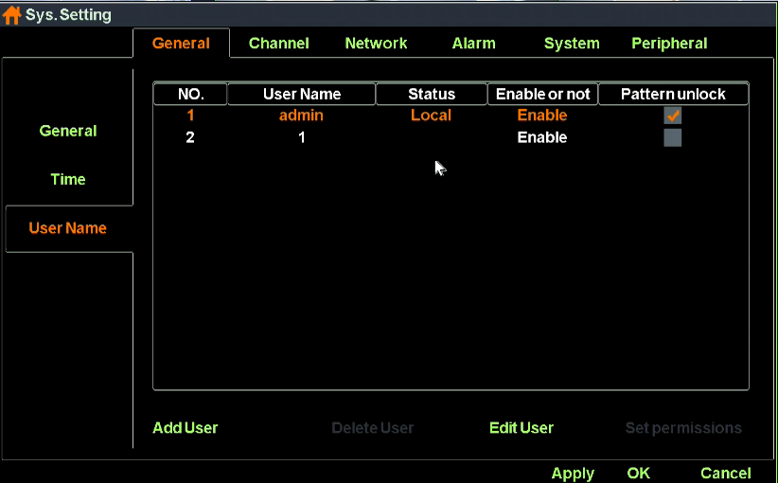
Function List:
Function Name | Function Description | Remarks
User List | Show local and network user list
“Add”Button | Add new user name and password,check if it is available | Add the same user name
“Edit”Button | Edit existing user information,like password | Admin user can’t close
“Delete”Button | Delete new added user information | Admin user can’t delete
Set Permission | Set user permission | admin user own all permission
Pattern unlock | Set pattern lock for user
Local user permission list
Local user permission | Permission explaination
System setting | Own all operation permission
Manual recording | 0wn channel start/close and manual recording operation permission
Playback | Own channel recording playback operation permission
Preview | Own channel preview permission
PTZ control | Own PTZ control/ call preset/call route operation permission
File management | Own snapshot picture operation permission
Recording backup | Own recording backup operation permission
Close system | Own shutdown/restart operation permission
Email notice | Own alarm linkage send email operation permission
Network user permission list
Network user permission | Permission Explaination
System setting | Own remote system setting permission
Manual recording | Own remote set manual recording permission
Voice talkback | Own remote voice talkback operation permission
Remote playback | Own remote playback operation permission
Remote priview | Own remote connection/remote monitoring selected channel operation permission
PTZ control | Own remote PTZ control operation permission
Remote update | Own remote update operation permission
Close system | Own remote close system permission

Pattern unlock operation steps:
- Left click ‘system setting’ function in contextmenu and turn to ‘General-User Name’, tick ‘Pattern unlock’.
- Configure your own pattern lock according to the hint and confirm your pattern lock. As the following picture shows:
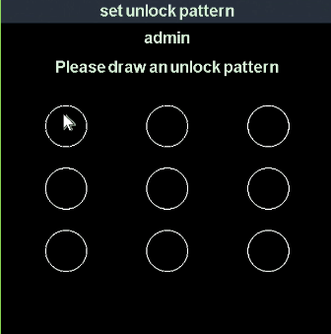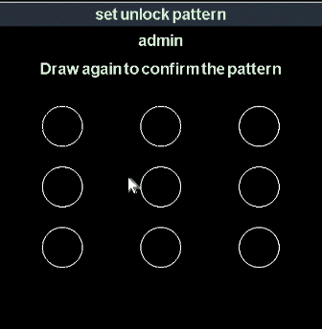

RS232 Setting
Function instruction: Used to set serial port parametres.
Operation steps:
- Left click ‘system setting’ function in contextmenu or in bottom menu and turn to system setting dialog.
- Turn to RS232 setting
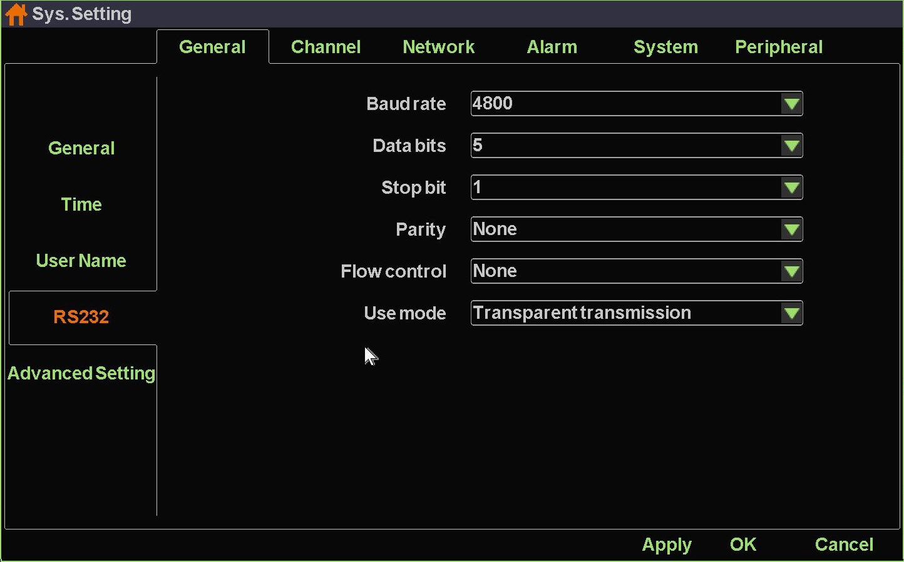
Function list:
Function Name | Function Description | Remarks
Baud rate | Used to set baud rate
Data-bits | Used to set data-bits
Stop-bits | Used to set stop-bits
Parity | Used to set parity
Flow control | Used to set flow control
Transport method | Used to set transparent transportation

Advanced Setting
Function instruction: Used to set preview mode, channel drag mode, disable smart features, disable unlogin preview, increase the channel capacity.
Operation steps:
- Left click ‘system setting’ function in contextmenu or in bottom menu and turn to system setting dialog.
- Turn to Advanced Setting dialog, as the following picture shows:
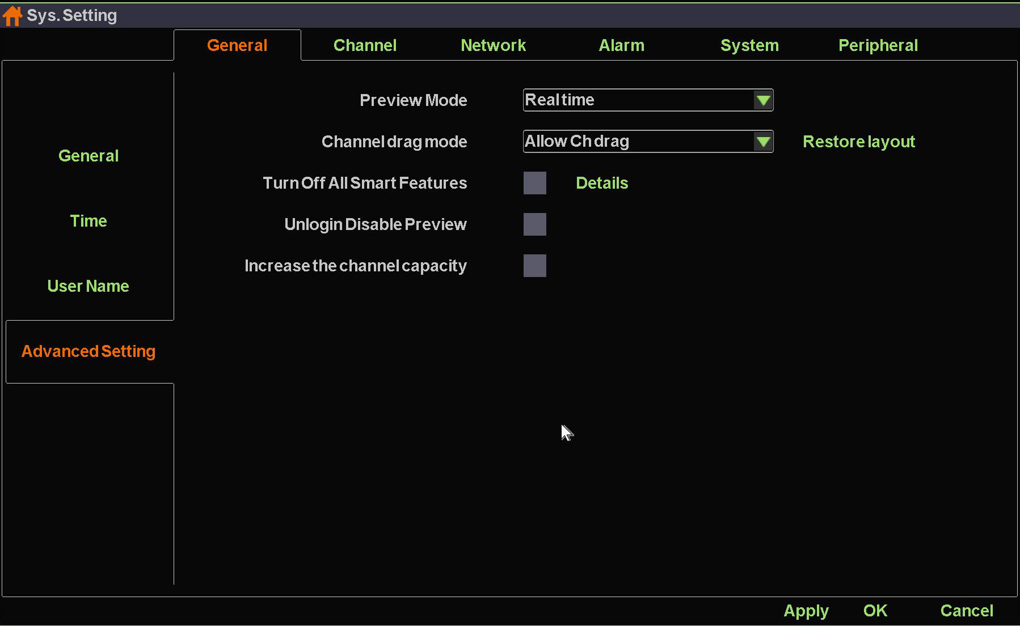
Detailed Function List:
Function Name | Function Description
Preview Mode | Used to set preview mode, including Real time mode and Smooth mode
Channel drag mode | Used to set channel drag mode, including directly switch channel stream, channel stream binding with channel number and no channel drag.
Turn off all smart features | If you tick the checkbox, NVR will turn off all intelligent configurations including adding IPC devices automatically, IPC config lock, NVR IP address conflict self-adaption and IPC IP address adaption.
Unlogin disable preview | If you tick the checkbox, you cannot see any video picture when you logout.
Increase the channel capacity | If you tick the checkbox, you will get a NVR with larger channel capacity and be able to use more channels.

Preview Setting
Function instruction: Used to set IPC stream parameters and OSD settings.
Operation steps
- Left click ‘system setting’ function in contextmenu or in bottom menu, then system open a new dialog.
- Left click into ‘channel preview setting’ in system setting window, system will open preview setting dialog as the following picture shows:
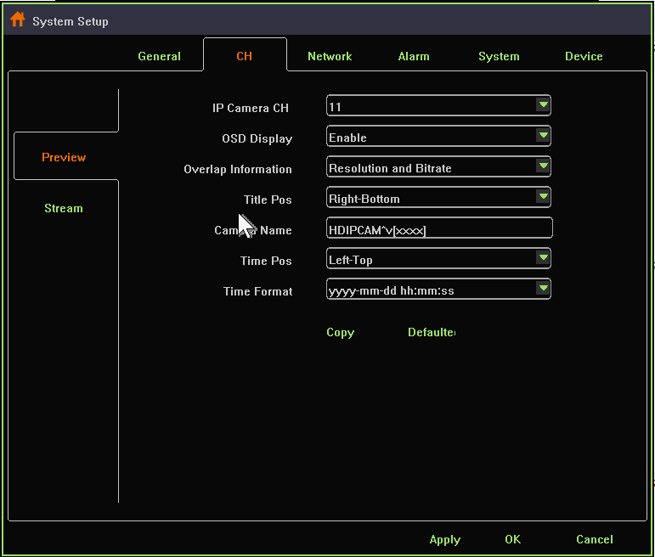
Detailed Function List:
Function Name | Function Description
IP Channel | Show the channel number of current setting
OSD Show | show/hide OSD info
Overlap additional information | Set overlap additional information, including ‘no overlay’,overlay resolution’,overlay code rate, “overlay resolution and code rate”
Headline position | Heading message positon setting, support top left,bottom left,top right,bottom right
Channel Name | Channel name setting, support number,character,capital and small letter and Chinese input
Time position | User set channel overlay position, support top left,bottom left,uppder right, bottom right
Time show format | User set channel time format

Stream Setting
Function instruction: set system channel’s main stream rate and sub stream parameter
Operation steps;
- Left click ‘system set’in contextmenu or in bottom menu,then system open a new window.
- Left click’channel’in system interface,system open a new dialog as the following picture shows:
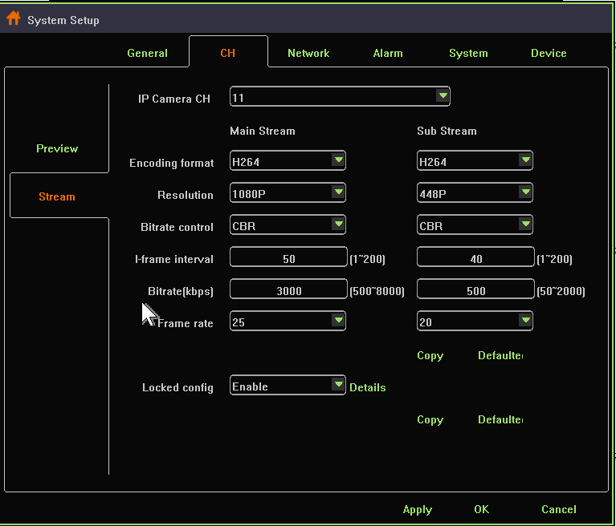
Detailed function list
Function name | Function Description
IP channel | Set current channel number
Encoding format | Main/sub stream encoding format setting,support H.264, H.265,H.265+.
Resolution ratio | Main/sub stream resolution ratio setting, NVR provide resolution ratio option based on IPC ability level
Bit rate control | Main/sub stream bitrate control setting,support VBR and CBR
I-frame interval | Main/sub stream I-frame interver setting, range from 1-200
Bit rate | Main/sub stream bit rate setting, range from 100~10000kbps
Frame rate | Main/sub stream frame rate setting, the larger the frame rate, the fluency is better
Locked Config | Enabled. If the device config are modified by NVR. It’ll be binded to device. Otherwise, It’ll be binded the most appropriate config.
Locked Config | Disabled. IPC encode parameters will not change unless NVR local config changes.

Network Setting
Function instruction: Configure network parameters and check out NVR device ID and P2P state.
Operation steps:
- Left click‘system setting’ in contextmenu or in bottom menu.
- Left click ‘network’,system will open network configure dialog.
Detailed Function List:
Function Name | Function Description | Remarks
IP Address | Show NVR’s IP address, support manual set and input IP address
Subnet Mask | Show NVR’s subnetmask
Gateway | Show NVR’IP gateway
Primary DNS | Show primary DNS information of NVR
Secondary DNS | Show reserve DNS information of NVR
MAC Address | Show MAC address information of NVR
Auto gain IP（DHCP） | Used to gain IP address automatically | When use DHCP, you can’t modify IP address manually
IP Self-adapt | Used to self-adapt IP address when IP conflict occurs
Cloud ID/Device ID | Show NVR device ID
Cloud state | Show NVR P2P state | You can remote access to NVR device only when the Cloud State is ‘online’
Cloud desktop show | Control whether you would like to see P2P state at the top of desktop
Cloud password setting | Used to set up or modify Cloud password
Details | Offer simple solutions when your NVR can not get online
Long network line support | If you tick the checkbox, your POE devices can support long network line transport. Otherwise, your POE devices can support at most 120m  Transport.
Close Vlan | Tick the checkbos if you need to search the POE devices in your LAN.

GB28181 Setting
Function instruction: NVR connect to surveillance platform with 28181 protocol.
Operation steps:
- Left click ‘system setting’ in contextmenu or in bottom menu
- Left click ‘Network-GB28181’ and turn to 28181 configure dialog, as the following picture shows:
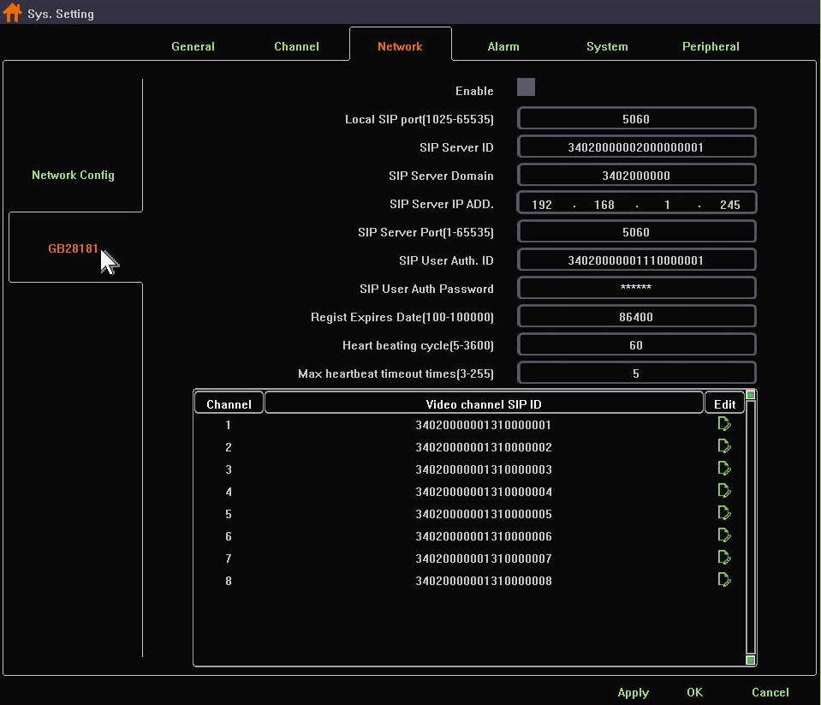
Detailed function list:
Function Name | Function Description
Enable | If ticked, NVR will start 28181 service
Local SIP port | Used to set Local SIP port
SIP Server ID | Used to set SIP Server ID
SIP Server Domain | Used to set SIP Server Domain
SIP Server IP ADD | Used to set SIP Server IP ADD
SIP Server Port(1-65535) | Used to set SIP Server IP ADD
SIP User Auth ID | Used to set SIP User Auth ID
SIP User Auth Password | Used to set SIP User Auth Password
Regist Expires Date(1-100000) | Used to set Regist Expires Date
Heart beating cycle(5-3600) | Used to set Heart beating cycle
Max hearbeat timeout time(3-255) | Used to set Max hearbeat timeout time

Email Setting
Function instruction: set email alarm parameter
Operation steps:
- Left click ‘system setting’ in contextmenu or in bottom menu.
- Left click’alarm’ in system setting window, click ‘OK’ button after finishing email configuration.
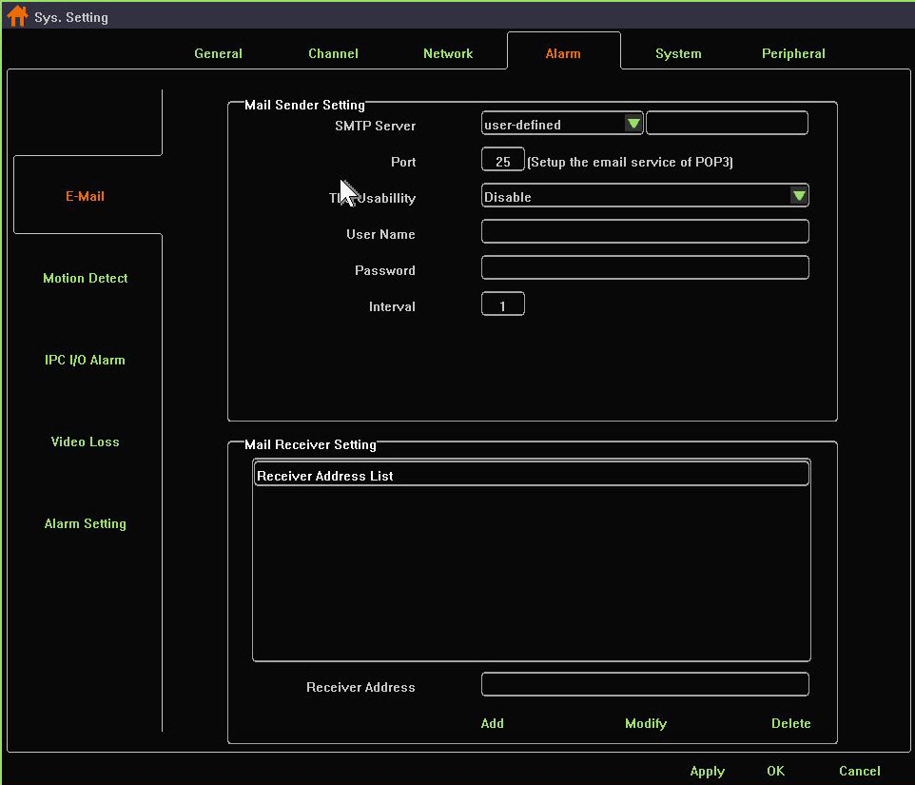
Detailed Function List:
Funciton Name | Function Description
Email Service | select email server name,including smtp.163.com, smtp.qq.com, smtp.mail.yahoo.com, smtp.126.com, smtp.qiye.163.com. You can alse customize smtp email address
Port | Set email server port number, default is 25
TLS usability | Control whether start email service’s encryption: support smtp.qq.com and smtp.mail.yahoo.com after you select ‘Enable’
User name | Mail sender’s username
Password | Mail sender’s password. Attention! You should use authorized code as your password if you choose qq mailbox, 126 mailbox or 163 mailbox company version.
Send interval | Mail send interval, default is one minute, you can’t send any other email in one minute
Recipient List | List all receivers’mail address
Receiver Address | Input receiver’s mailbox
“Modify”button | Modify the mail address in the recipient list
“Add”button | Add a new mail address to the recipient list
“Delete”button | Delete a mail address from the recipient list

Motion Detection Alarm
Function instruction: when Motion detected, NVR will trigger motion alarm.
Operation steps:
- Left click ‘system setting’’ in the contextmenu or in bottom menu.
- Left click ‘Motion detection’option in system setting window, system will open motion detection dialog. Tick off the Enable checkbox and start motion alarm
- Left click ‘setting’button, then you’all be able to change motion area of IPC device.
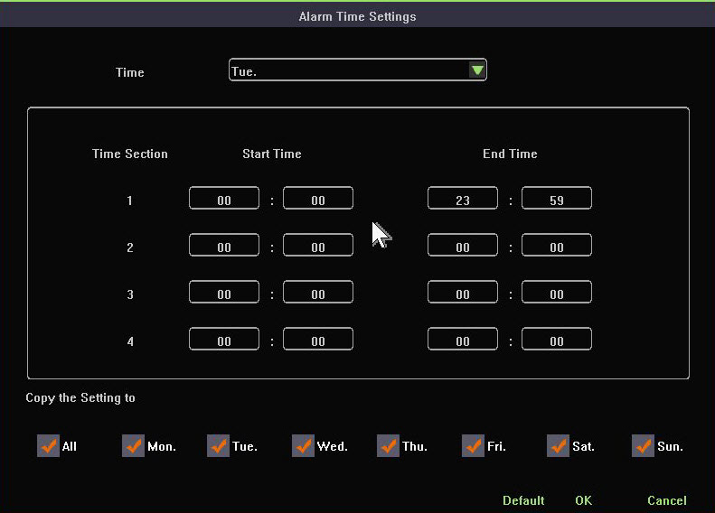
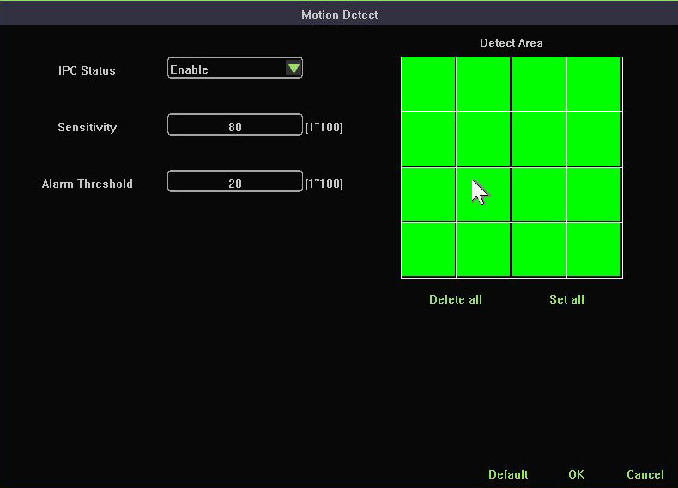
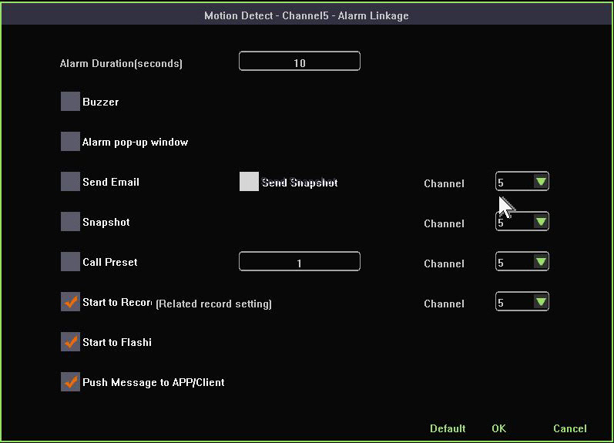
- Left click’alarm linkage’ button, you’ll be able to configure alarm items in the dialog.
Detailed Function List:
Function Name | Function Description | Remarks
Alarm lasting time setting | Used to set how long the motion alarm lasts
Buzzer alarm | Control whether to activate buzzer alarm
Alarm pop-up window | NVR change current lay-out to whick include all motion devices
Email alarm | Control whether to send email when motion alarm detected
Send screenshot | Control whether to add attachment when sending an email
Snapshot image | Control whether to grab images when motion alarm detected
Call preset | Control whether to adjust PTZ device current position when motion detected
Start recording | Control whether to record when motion alarm detected
Flashing | Control whether to flashing when motion alarm detected
Push Message to APP/client | NVR send alarm message to your APP when alarm incident happens

Video Lost Alarm
Function instruction: NVR will trigger alarm after detecting video lost
Operation steps:
- Left click ‘system setting’ in contextmenu or in bottom window.
- Left click ‘stream lost’ in system setting window, system turns to a new dialog. Tick off the Enable checkbox to start video lost alarm.

- Left click ‘alarm linkage’ button., you’ll be able to configure alarm items in the dialog
Detailed Function List:
Function Name | Function Description | Remarks
Alarm lasting time setting | Used to set how long the motion alarm lasts
Buzzer alarm | Control whether to activate buzzer alarm
Alarm pop-up window | NVR change current lay-out to whick include all motion devices
Email alarm | Control whether to send email when motion alarm detected
Call preset | Control whether to adjust PTZ device current position when motion detected
Push Message to APP/client | NVR send alarm message to your APP when alarm incident happens

Local I/O Alarm Setting
Function instruction: Used to receive alarm input and to process alarm linkage.
Operation steps:
- Left click ‘system setting’ in contextmenu or in bottom menu.
- Left click ‘Local I/O Alarm Setting’ and configure ‘Defence Time’, ‘Alarm Linkage’. As the following picture shows:
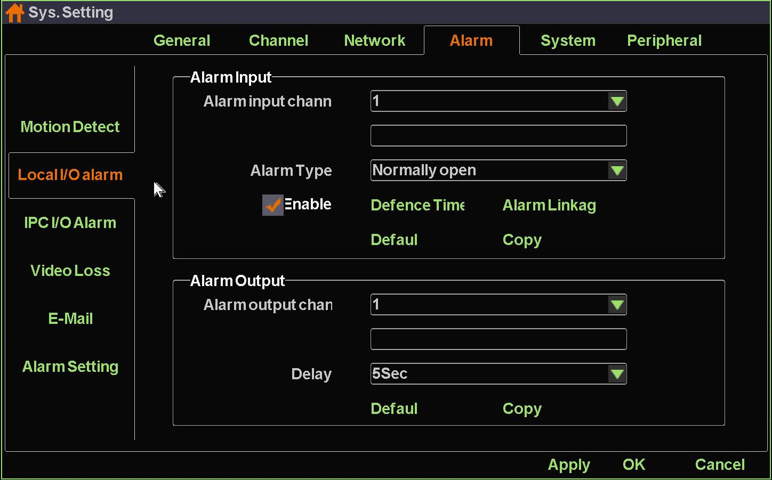
Detailed function list:
 | Function Name | Function Description
Alarm Input | Alarm type | Used to open or close alarm input
Alarm Input | Defence time | Used to set local alarm time schedule
Alarm Input | Alarm linkage | Used to set local alarm linkage including buzzer, email, snapshot, preset call, flashing and etc.
Alarm Input | Default | Set all parametres to default
Alarm Input | Copy | Copy current channel configuration to other channels
Alarm Output | Alarm output channel | Used to select channel
Alarm Output | Delay | Used to set alarm output delay
Alarm Output | Default | Set all parametres to default
Alarm Output | Copy | Copy current channel configuration to other channels

IPC I/O Alarm Setting
Function instruction: NVR process alarm linkage when receive I/O alarm message from IPC devices.
Operation steps:
- Left click ‘system setting’in contextmenu or in bottom window
2．Left click ‘IPC I/O Alarm Setting’ and configure ‘Defence Time’, ‘Alarm Linkage’. As the following picture shows:
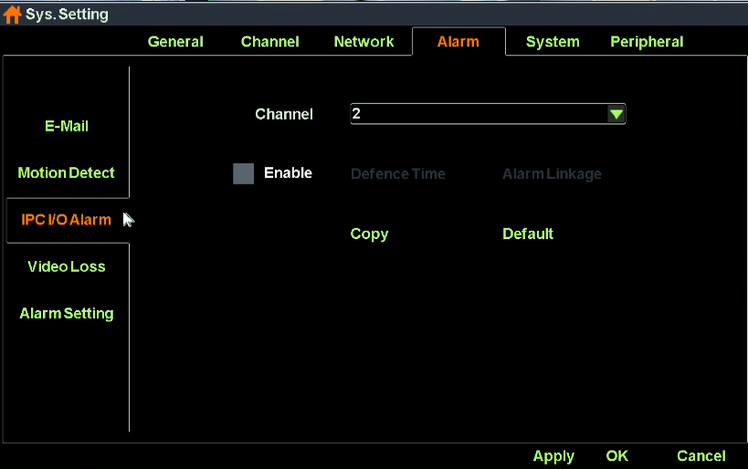
Detailed function list:
Function Name | Function Description | Remarks
Alarm lasting time setting | Used to set how long the motion alarm lasts
Buzzer alarm | Control whether to activate buzzer alarm
Alarm pop-up window | NVR change current lay-out to whick include all motion devices
Email alarm | Control whether to send email when motion alarm detected
Send screenshot | Control whether to add attachment when sending an email
Snapshot image | Control whether to grab images when motion alarm detected
Call preset | Control whether to adjust PTZ device current position when motion detected
Start recording | Control whether to record when motion alarm detected
Flashing | Control whether to flashing when motion alarm detected
Push Message to APP/client | NVR send alarm message to your APP when alarm incident happens

Advanced Alarm Setting
Function instruction: Used to configure alarm switch, buzzer switch, abnormal alarm push to mailbox, abnormal alarm push to APP.
Operation steps:
- Left click ‘system setting’in contextmenu or in bottom window.
- Left click ‘Alarm-Alarm Setting’ and turn to Alarm Setting dialog, as the following picture shows:
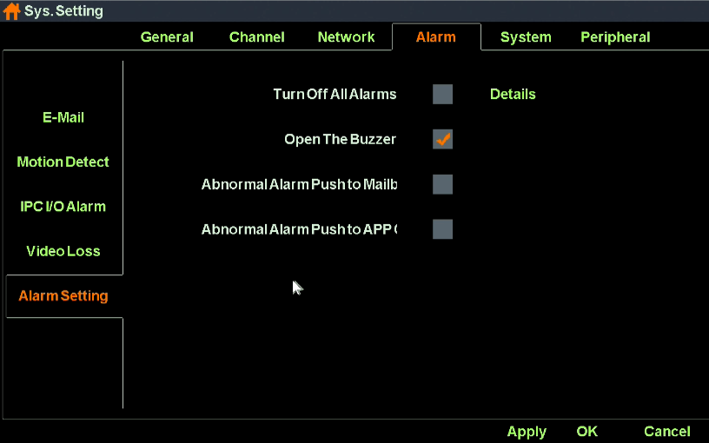
Detailed function list:
Function Name | Function Description | Remarks
Turn off all alarms | Control NVR whether to open alarm switch
Open the buzzer | Control whether buzzer works
Abnormal alarm push to mailbox | Control whether to enable email sending when alarm incident happens
Abnormal alarm push to APP/Client | Control whether to enable APP push when alarm incident happens

System Log
Function instruction: Used to search and export NVR’s log information
Operation steps:
- Left click ‘system setting’in contextmenu or in bottom window.
- Left click‘system-log’ in system setting window. The system turns to a new dialog as the following picture shows:
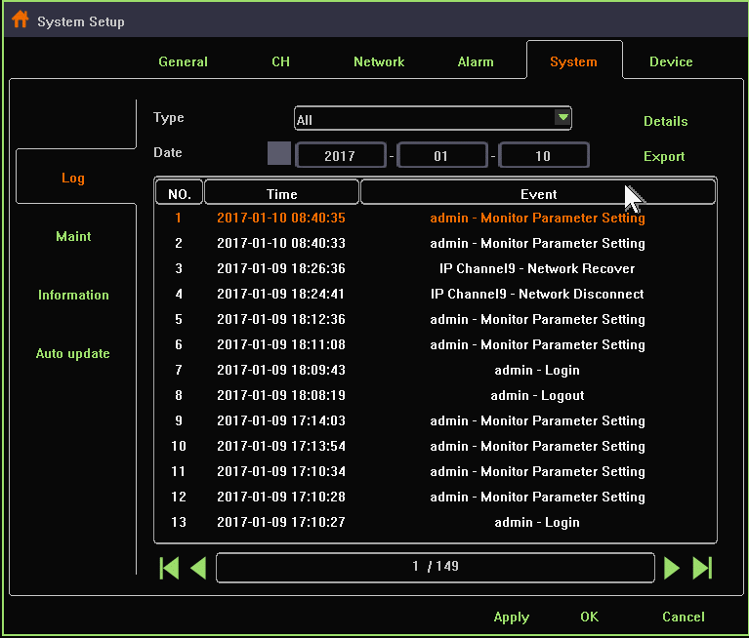
- You can search log by changing ‘type’ and ‘date’ settings.For detail info, click on ‘Details’ button.
- Left click’export’ button,you can export selected item in the list to your u-disk or other storage devices.

System Maintenance
Function instruction: Maintain the NVR system, including restart system according to schedule,upgrade using u-disk, reset factory, import/export
Operation steps;
- Left click ‘system setting’in contextmenu or in bottom menu
- Left click ‘maintain’in system setting window, system turns to ‘system maintenance’.
Detailed Function List:
Function Name | Function Description | Remarks
Reboot Setup | Restart system according to schedule | Default state is close
Update type | Different way to upgrade system
Update | Used to upgrade system by u-disk | Do not power off when updateing, or else NVR can’t restart
Export | Export current configuration to storage devices
Import | Import configuration from u-disk to NVR system
Reset factory setting | Simple recovery, recover system configuration except Network settings and Cloud password setting
Reset factory setting | Complete recovery, completely restore all system configuration to factory settings

System Basic Information
Function instruction: Used to show NVR system information,including product model,device ID,product serial number, software version, hardware version,website, QR code
Operation steps;
- Left click ‘system setting’in contextmenu or in bottom menu.
- Left click ‘system information’ in system setting window, system turns to ‘information’ dialog.

Auto Upgrade
Function instruction:Used to upgrade through web server online.
Operation steps:
1. Left click ‘system setting’ in contextmenu or in bottom menu.
2. Left click ‘auto upgrade’ in system setting window, system turns to ‘Auto upgrade’ dialog.
REMARKS: You must ensure that your NVR have connected to the Internet.
Detailed Function List:
Function Name | Function Description | Remarks
Check | Used to check whether there’s new version on the remote server | The dialog shows ‘The current version is up to date’ if there’s no latest version. Besides, The dialog shows the latest version if there’s new software version
Upgrade | Left click to update to latest version | Be sure that your NVR have already connected to Internet before upgrade.
Auto upgrade | Used to upgrade automatically
Upgrade time | Used to set auto-upgrade time | This setting come into effect only when you Tick off ‘Auto upgrade’

Storage Device
Function instruction: Used to check disk information, HDD formatting
Operation steps:
- Left click ‘system setting ‘ in contextmenu or in bottom menu.
- Left click ‘Device’ in system setting window, system turns to ‘Device’ dialog as the following picture shows:
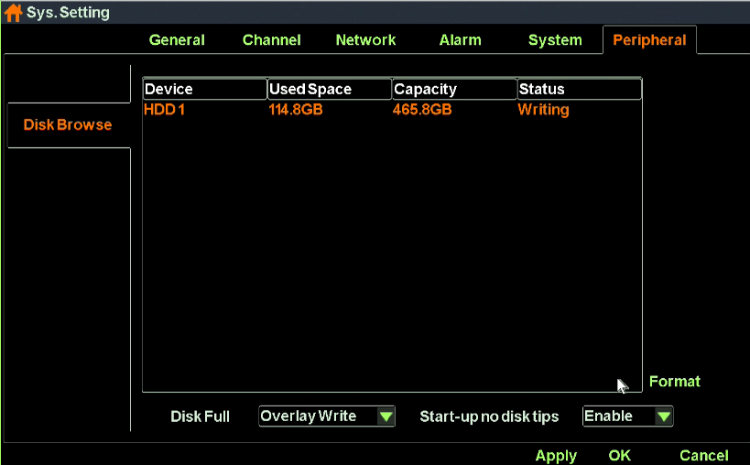
- Select one item in the storage device list. Click ‘Formatting’ button to format HDD. For large-disk NVR，you need to choose all disks that you want to format. And then click ‘Formatting’ button to format HDD. As the following picture shows:
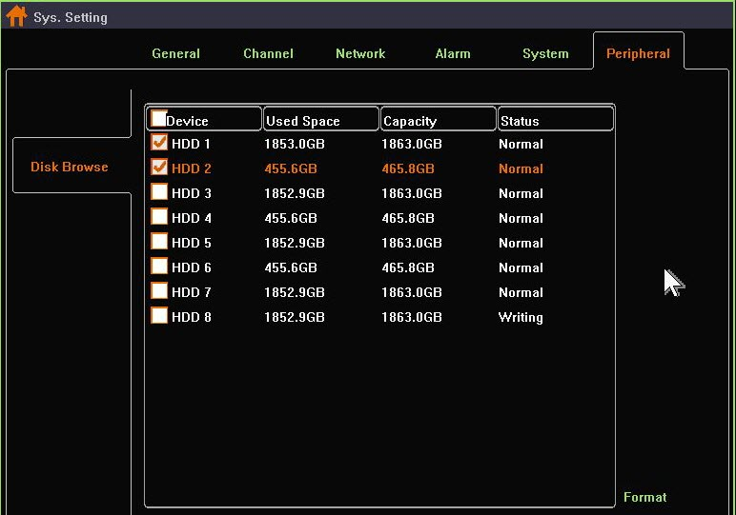
- We also provide different strategies when your HDD is full. ‘Overlay Write’ will continue to record and overlap the earliest video recording data. You can also select ‘stop recording’ as your strategy that NVR stops recording as soon as the HDD is full.

Appendix

Hard Disk Capacity Calculation
Code Rate | Recording File Size/Day/Channel
1000kbps | 10G
2000kbps | 20G
3000kbps | 30G
4000kbps | 40G
5000kbps | 50G

Hard Disk Total Capacity Corresponding Video Days Calculation
HDD total capacity | Chanel Number | Resolution Ratio | Video Days
8T | 8 | 960P×8 | 80 days
8T | 8 | 1080P×8 | 50 days
8T | 16 | 960P×16 | 40 days
8T | 16 | 1080P×16 | 25 days
8T×2 | 25 | 960P×25 | 50 days
8T×2 | 25 | 1080P×25 | 32 days
8T×2 | 36 | 960P×36 | 35 days
8T×2 | 36 | 1080P×36 | 22 days
Remarks: the above data is calculated by H.264 & low rate bite, when onvif IPC access NVR, the video days will reduce half.

HDD total capacity | Chanel Number | Resolution Ratio | Video Days
8T | 8 | 2MP× 8 | 125 days
8T | 8 | 5MP×8 | 83 days
8T | 16 | 2MP×16 | 62 days
8T | 16 | 5MP×16 | 41 days
8T×2 | 25 | 2MP×25 | 80 days
8T×2 | 25 | 5MP×25 | 53 days
8T×2 | 36 | 2MP×36 | 55 days
8T×2 | 36 | 5MP×36 | 37 days
Remarks: the above data is calculated by H.265+ & low rate bite, with single channel 2MP 4GB~8GB/Day, 5MP 6GB~12GB/Day

FAQ
- What is NVR default user name and password？
user name : admin, password: 123456

2. Why I can see nothing when I start the system?
Step 1:Check NVR if it has electricity, user can check mouse lamp,ethernet port and so on, we suggest use NVR standard power
Step 2: Check display resolution, our NVR default resolution: 1024x768. When the maxium resolution of display is less than NVR, there is no interface output
Step3:Check interface if there is output after deleting all outside device and power on by itself, our NVR support VGA output and HDMI signal

3. After starting interface, it prompts ‘NO HDD’
Step 1:Confirm NVR to connect regular hard disk without fault
Step 2:Confirming NVR’s power is enough, we suggest customer to use standard power.
Step 3:Confirming NVR HDD power interface and SATA interface is normal

4. User can’t check cloud ID
Step 1:NVR only can gain cloud ID after connecting internet, it can check cloud ID through moving mouse to the margin top of main interface
Step 2:Enter NVR’s main interface, click right key,enter’system setting-system-basic information’, check product serial number if it is legal,the illegal serial number begin with “FFFFFFFF********“

5. Video management page can’t search IPC
Step1:Check NVR if it is connected to cable, we can check Ethernet port flicker to judge
Step2:If user can’t search ONVIF IPC, please confirm ONVIF IPC AND NVR is in the same network segment, confirm IPC to support ONVIF 2.1 and above version

6. Prompt channel is kicked out
Step1:The IPC total bandwidth to NVR is limited, when channel is kicked out, please reduce relative channel code rate

7. When multi channel NVR connect IPC, Video happen blocked, no smooth,off line
Step 1:We suggest user to use gigabit switch when IPC channel to connect NVR is more than 16CH

